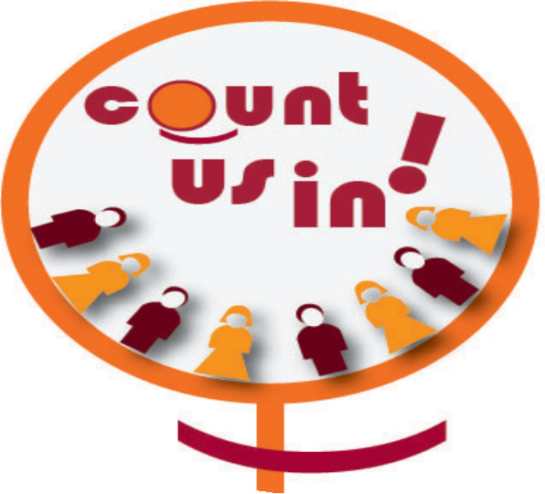

Sign up form

Our national centre supports the “Count us in!”
campaign because equality builds workers power.

I ……………………………….. (name and position of the leader) support the aims of the “Count us in!” Campaign and will submit by
………….…. (date) an action plan indicating how and by when we will achieve at least 30% of women in our decision making bodies.

I also commit to supporting and facilitating the recruitment of women in our organization to achieve the objective of +5% women membership by the 4th ITUC Congress in 2018

Union leader’s signature: Name:
Position: National Centre: Country:
Contact person and email address:

For monitoring purposes, we kindly ask you to provide the following information:

What is the decision making body you will focus on to achieve at least 30%
women participation?

What is the total number of members in this body today?

How many women?

How many men?

Are there any women in the 5 top leader positions of your organisation?

If yes, indicate name and position:

What is the total number of members in your organisation?

How many men?

How many women?

Please attach reports and resource materials related to the “Count us in”
campaign.

PLEASE SEND BACK THE SIGN UP FORM TO: equality@ituc-csi.org

