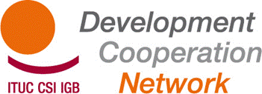

Report TUDCN General Meeting – 14-15 November 2012 – Paris OECD

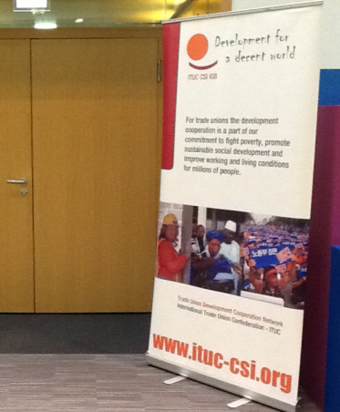

DAY 1. Wednesday 14 November 2012
Participants: see participants list in annex
Opening of the meeting – adoption of the agenda
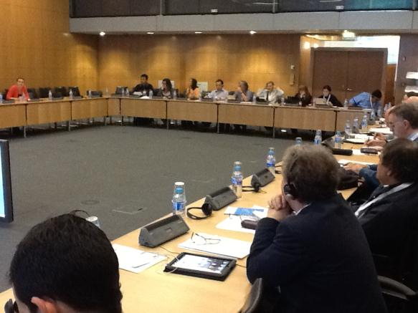The meeting starts at 9:45 am. Jan Dereymaeker (ITUC/TUDCN) welcomes the participants and informs them. About the day of action today organised by the ETUC. The French unions organise a manifestation at 1:00 pm. All participants of the General Meeting are invited to join. He also informs the meeting that everyone is invited for dinner by the French unions CFDT and CGT tonight.
This is followed by a brief presentation of each participant.
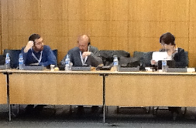
Jan gives comments on the agenda and highlights the last minute changes. The agenda is approved.
Pierre Coutaz (CGT) welcomes the participants on behalf of CFDT and CGT. It is for the first time that the General Meeting is hosted in France. In these days the Minister of Development cooperation in France organises “Les assises du development” (general hearings on development policies) In France, as in many countries in Europe, today is a day of trade union action. The solidarity from the participants of this meeting in the manifestation in Paris will be highly appreciated.
Report of the previous meeting
The report of the previous General Meeting in Helsingor (Denmark) has been made available for everyone. No remarks were received. The report is approved.
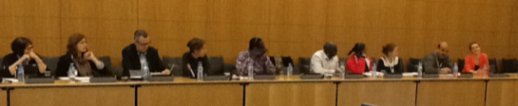
Progress on post Busan process
Eduardo Gonzales (OECD) presented the progress on post- Busan process and OECD/DAC Development Strategy
In the last five years there was an important evolution: the diversity in actors and forms of cooperation has increased. There is recognition of the importance of other forms of development cooperation. Aid can be a catalyst. We see an evolution from aid effectiveness to effective development cooperation.
Focus is on country level monitoring, with specific indicators, complemented with an international monitoring framework comprising ten global indicators. Five of them are new, with special attention for indicator 2 on the role of civil society.
The follow up of Busan is organised through the Global Partnership for Effective Development Cooperation (GPEDC). In December 2012 the first Steering Committee Meeting will take place. In the fall of 2013 there will be a first Ministerial Meeting.
In his reply, Jan recalls the Trade Unions positions .Busan was a success when it comes to include much more actors than before. It was probably a turning point in the thinking on aid: Busan represents the end of aid, and focus on development. Economic growth is presented as the motor for development. However according to us, growth is important, but it is not the motor for development. New elements are coming up, like social protection. This is a challenge for us.
For the time being, Trade Unions have no seat in the Steering Committee of the GPEDC in December in London, while the employers – BIAC – do. This should change. Given the change in focus from aid to development, Trade Unions should be recognised as important partners in this debate. Finally, there seems to be an emerging overlap between this post Busan process and the one on post 2015. The risk is that, given the donor ‘fatigue’ following Busan, the post 2015 process gathers political priority leaving the post Busan as a possible unfinished business.
Stijn Sintubin (CSC) asks for information around the building blocks and the follow-up of Busan. He points out that two tracks seem to exist regarding development: one followed by those who have signed the Paris Declaration, and one followed by those who have not. To what extend is it possible not to apply certain aspects of the Paris Declaration?
Mamadou Faye (CNTS) comments on the ten global indicators. He has the impression that the role of the Trade Unions in the process is not valued or supported, especially in Africa.
Sergio Bassoli (CGIL) is of the opinion that the actual scheme is not working, is not helping to solve the problems of poverty. Every ten years the scheme changes, but poverty and war still exist. We must focus and defend the basic rights, the right of freedom of association.
Santiago Vallejos (USO) asks whether the OECD is interested in the participation of Trade Unions in the process.
In his reply, Eduardo Gonzales indicates that the wording Development Cooperation Effectiveness now also includes aspects as private sector, anti-corruption, effective institutions. Busan could have produced nice declarations, but most important is the possibility to make progress on implementation. On the two tracks, he agrees that it would be better if everyone would engage fully on the Paris and Accra commitments. But the reality is different; it does not work to try to impose these on new partners. The Busan Partnership remains a ‘coalitions of the willing’. Trade Unions have no seat in the Steering Committee, but this should not represent a problem. Influence is possible on other levels.
In his conclusion, Jan argues that this debate is not closed. The recognition of the Trade Unions as important actors in development remains an important issue for the TUDCN/TUAC/ITUC. After Busan there was a tendency within the governments not to include the trade unions in the process. A proper seat at the table for the trade unions, separate from the one for the civil society, is still refused. We have to continue our lobby work towards our government to change this.
As for the BBs , which are supposed to be implemented at country level in the South, there are no concrete processes involving all stakeholders; in particular, participation from Southern actors is almost missing.
Progress on EU policies , post Busan UNDCF, UN +2015 and South South Cooperation
See power point presentation by the TUDCN secretariat at http://www.ituc-csi.org/documentation-from-the-meeting,12575
Gemma Arpaia (ISCOS) thanks the secretariat for all the work and the results that have been delivered for the network.
In the discussion with the members of the General Meeting, following elements were raised:
- The topic of decent work has to be taken up as part of the human rights approaches.
- The statement on South-South Cooperation is to be finalised.
- What is the status of Trade Unions in the High Level panels of Post 2015? The employers are represented.
- National structures are the main targets for action on the development process. The newsletter is important for interaction between national and international level.
- The report on results is appreciated. A comparison between the initial objectives and where we stand now would be useful.

Working Groups on Policy Area Progress Reports
Participants were asked to analyse the outcomes report of the TUDCN in terms of relevance of the topics addressed, and on the choice of future priorities/strategies.
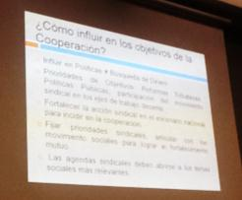 | 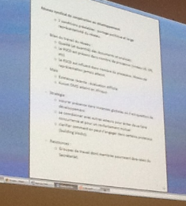
Report of the Spanish working group:
- The post Busan work at national level is about advocacy and influencing policies, not about funding for trade union activities or actions.
- For trade union participation, priorities in development policies are related to tax reform, public policies and the decent work agenda.
- We need to strengthen our presence, advocacy and participation in policy debates at national level in order to have an increased impact on development.
- We should push for our priorities in coalition with other social movements
- Also our agenda’s should take into account the broader social demands and needs
Report of the English working group:
On the Post 2015 framework:
- The trade unions should also be included in the discussions on education.
- We must develop our views and communicate them on the meaning of decent work and on our key indicators.
- We have to inform the trade unions on the planned country level consultations to allow them to prepare for these consultations.

Report of the French working group:

- Assessment of TUDCN’s work:
o Positive assessment of the quality (and quantity) of the policy documents and analyses produced.
o TUDCN is present in a number of important processes (level EU, UN, etc.)
o TUDCN is influential in many processes and ensuring a level of TUs representation never achieved before.
o However, political support and broad recognition of the network as the place for joint policy action and cooperation in development should be granted by TUDCN members, including ITUC political instances

- Strategy for TUDCN:
o keeping ensuring presence in global instances on development policies
o coordinate with others CSOs actors to be mutually reinforcing
o better clarify how we can engage in some process (i.e. making practical guidelines on building blocks, like it was done for the post 2015 process).
- Resources to the TUDCN:
o possible proposal: setting up ‘task forces’ (smaller than the current Working Groups), whose members would be in charge of following a specific dossier/theme together with the Secretariat In his closing remarks, Jan underlined that the cross cutting agenda of the Trade Unions is Decent Work. As from there, we should be able to formulate a coherent and consistent position on the meaning of Development from the trade union point of view.

Other business
During the day, 2 PRESENTATIONS were made, one by the TUC on its case study on Decent Work and DFID policies and the other one presenting the new ITUC/TUDCN database.
“A Decent Job?”: Ben Moxham (TUC) presents the TUC study assessing the UK Department for International Development (DFID) on Decent Work. The TUC states that the DFID approach to Decent Work in development is largely insufficient. You can find the presentation here.
Trade Union Development Projects Directory: Marion Levillain presents the Trade Union Development Projects Directory. It contains currently information on around 260 projects. In the debate clarification is given on the methods of keeping the database updated, and on the classification of multi donor projects. http://projects.ituc-csi.org/
Jan informs the General Meeting that Bandula Kothalawala (TUC) had returned home due to the decease of his mother. The participants signed a card to express their condolences.

DAY 2: THURSDAY 15 NOVEMBER 2012

Martha Ayala (TUCA) gives an overview of the program of the day.
Jan introduces Dirk Van Esbroeck who has been contracted as evaluator of the TUDCN project and will assist at the General Meeting as an observer.
Progress reports form regional organisations, TUSSOs and GUFs
Adrien Akouete (ITUC Africa) gives an overview of the situation in ITUC Africa and Martha Ayala (TUCA) comments on priorities and work plan of TUCA in Latin America.
Antonia de Lisboa Amancio Valle (CUT Brazil) informed on their cooperation with Haiti, Honduras, and on technical cooperation with Mozambique. Marita Gonzalez (CGT Argentina) explains the work on Decent Work and Myriam Luz Triana (CGT Colombia) reports on the recent contacts to engage with the government in Colombia on international cooperation.
Luciano Robles (CASC Dominican Republic) explains how the seminar on south south/LA network helped the trade unions in his country to progress on the reform of the countries’ cooperation policy. He also gave details on the cooperation program with Haiti.
Stijn Sintubin (ACV-CSC Belgium) explains that the Belgian government developed strategy papers and a legislation around development cooperation included decent work as an important element. However now that the financing system is on the table, space for trade unions seems to be reduced.
Frédérique Lellouche (CFDT) describes the process of consultation in France, initiated by the new Minister of Development that will take 4 months. The topics are: Beyond 2015, Transparency, Efficiency, Partnerships and Innovation in development. The trade unions hope that they will be listened to during this process. Until now the focus was mostly on the LDCs, and the approach NGO oriented.
Santiago Vallejos (USO) highlights the discussions with the Spanish government. The trade unions defend Decent Work, the government stimulates the PPS. Budgets will be reduced. NGOs will have smaller budgets and limited possibilities.
Lars Bengtsson (TCO) informs the meeting that the Swedish government has announced a new platform for dialogue, but this is not yet presented. The Minister is a strong promoter of business and private sector. She is member of the High Level Panel, travels a lot and invests much time in influencing other countries. The budget for next year has been presented, there is no reduction. SIDA is being reorganised; business for development becomes important. These people have not much interest in speaking with trade unions.
Gemma (ISCOS) points out that there is no real collaboration in Italy between the minister of foreign affairs and the minister of development cooperation. A new trend in financing development is visible, with more funds for ODA, for fewer countries (21 countries).
Eduard Parsaulian (KSBSI) explains how in Indonesia tripartite dialogue exists, facilitated by the ILO. There is dialogue about the Decent Work country program. New legislation for Social Security – actually only applicable in the public sector – would be extended to all workers in 2014. The ILO and the Government support programs for small companies on good management and environment.
Josée Roy (CSN) explains the many changes in Quebec/Canada due to the conservative government. NGOs and trade unions are now put in competition with other private organisations. Trade unions do not receive funds since last year. Cooperation is now handled with private companies in the mining sector, companies without experience in development aid.
TUDCN programme, working methods and governance
Kasia points out that the objective of the discussion in working groups should be to reflect on programme and methods. The list of questions is long, but this is merely to guide the discussion. Focus should go to the elements that are good, that should be kept, how things could be improved, and what is relevant.
Report of the English working group
- TUDCN has a recognised impact through its policy and advocacy work
- It is important for the trade unions to become more professional in assessing and monitoring our programs
- The material developed by TUDCN is good not only for training purposes, but also as support for policy and negotiations: building stronger credibility vis-à-vis the donor governments based on our relations with southern affiliates.
- More commitment of the GUFs is important.
- The negotiations by the secretariat in Brussels with the EU are very helpful for trade unions in negotiations on local level with the EU delegations or embassies.
- TUDCN should strengthen more the regional dimension in the south: bringing meetings in the regions….towards setting regional development networks
- A better balance should be found during the General Meetings between networking and reporting / informing, as well as, between policies and technical issues
- Receiving the agenda and the documents in time would allow us to be better prepared for the meetings.
- The work of the Working Groups should be evaluated. A question for the EU Working group should be: how can we influence the agenda setting proactively, instead of only react? The communication is good and efficient. Would it help to have more working languages?
Report of the French working group
The Network’s relevance
- The network has ensured that TUs are now recognised by the UN
- The network has improved the flow of information about what’s happening, particularly in Africa
- The network is still in its infancy and is not adequately accompanied by the ITUC policy (although this is the case in the regions)
- The network made the trade union voice heard in Busan
- Enabled the TUs to work together in certain areas on common themes
- The network will enable TUs with different levels of involvement in cooperation, to learn on one hand and on the other, to build coordination by physically bringing the TUs together at meetings.
- The network makes us more credible to external actors
- Enables us to speak with one voice in the forums.
- All outputs were very relevant and very valuable to the political processes.
Miscellaneous suggestions regarding the issues discussed
- Representation is a considerable challenge. How can the national trade unions organisations (TU) support the secretariat differently by/over and above their regular work?
- On the major international consultations (ex.: post 2015) everyone must work on national level and target the TUs in the countries where political leaders play a key role.
- Make greater use of the regional organisations and the ETUC for lobbying
- Important organisations were absent. We must find a way to interest them.
- Clarify the network status. It was set up by the ITUC. It invites other organisations. Who is the network’s decision maker?
- Produce a brochure providing information about the network, its composition, its actions to date, to publicise the network and for recruitment purposes.
- Would the TUs agree to do some work at home on certain things? Meeting preparation. Receiving the agenda in advance. Having a detailed agenda so that we can be prepared. Those involved would like to maximise their participation.
- To ensure greater involvement by the regions, decentralise so that the work can be carried out on the ground (ex. : Busan consultations)
- In the next programme, define the action areas, promote synergies, and update the database.
- Add a thematic seminar on to the AGM. This could be an attraction particularly if the AGM is held in the regions. And it is important for profile-building.
- Avoid exclusion by remaining very accessible in annual general meeting (avoid acronyms, closed language, etc.)
- The FSG is not visible: it should be tasked with following up on the discussions’ results and making recommendations.
- Allow time at the AGM for more exchanges on best practices, successes, failures.
- Group work would enable thematic exchanges on peoples’ actual work.
- The Website and the newsletter are greatly appreciated by all.

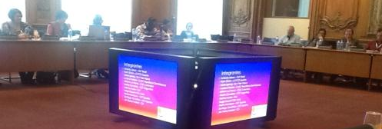

Report of the Spanish-Portuguese working group
Results from Busan
- This is the first time that social society has been involved but they did not take part in the final draft.
- Has enabled the strengthening of alliances with other civil society groups and intervention on decent work.
- The ILO should be considered as a strategic ally.
- The aid architecture could make us lose sight of our priorities
- Put emphasis on Our agenda and not on other actor’s agenda.
Cooperation objectives
- The cooperation is not going directly to the intended recipients but to the elite; the task is to review the intervention and to follow up on the results.
- Cooperation cannot coexist with dominance by a policy of plundering on the international economic stage.
- The fundamental ILO principles should be the horizon of our priorities and as such our achievement indicator.
- Cooperation should be guided by political objectives. The trade union movement is not guided by money but by solidarity.
How to influence Cooperation objectives?
- Influencing policies ≠ Searching for funds
- Ranking the Objectives: Tax Reform, Public policies, trade union participation in the decent work pillars.
- Strengthen trade union action on the national stage to influence cooperation.
- Set trade union priorities; coordinate with social movements for mutual benefit.
- Trade union agendas should include more relevant social themes.
Next intervention plan
- Implementation of the Decent Work Principles: indicators on the dimensions.
- Building peoples’ power and strengthening democracy.
- Fight Corruption: Taxation
- Achievement indicators: ILO participation, and the inclusion of decent work dimensions.
Strategic Planning Scenarios
- Specific actions
- Develop structured dialogue with the government to focus on the central objective of citizenship and democracy.
- Map of the tax bases in the regions.
- In the Busan declaration, the governments committed to specific actions. It is necessary to identify those commitments.

In his answer on the questions raised in the working groups before lunch, Jan explains how the first step in the program was to harmonise and coordinate. This was necessary to be able to progress. In this way the principles of trade union development cooperation were developed and published as a standard reference.
Another task was to get involved in the different global development debates and to introduce the trade unions as development actors with their specific agenda.
One of the objectives from the start was to involve the organisations of the south, to include the regional organisations in the network and in the working groups.
The network is not a closed network for ITUC affiliates only. Also GUFs and SSOs are included in the cooperation. The open character of the network raises the issue of its legitimacy.
Jan explains that the Facilitation and Steering Group is composed of two members from ITUC, two from the SSOs, two from the GUFs, and two from the regional organisations and includes the TUAC and ETUC.
The working groups are the EU working group, the working group on methodology. Ad-hoc working groups are created when necessary, as for Busan for example.
TUDCN Objectives and Work Plan for the future
Maurice Bossuat (CFDT) explains how the work of the meeting will be organised for the rest of the afternoon. He asks Jan to give more information on the plans for 2013-2016 for TUDCN.
Jan explains the issues that are on the table for discussion regarding the future work plan and on the working methods of the network:
- Should we reduce the number of General Meetings to one per year?
- Is the FSG a good system of working?
- The working groups delegate often the detailed execution of the tasks and decisions to the secretariat in Brussels. Is there a way to involve also the members of the network in this work?
From the discussion can be noted (that )
- It is important work with a large membership and not only with experts.
- There is no overkill in meetings yet. If the he evolution on global level has be followed up we also need time for training for ourselves and for the new members
- One General Meeting could focus on one main issue. The second could be planning & evaluation.
- There was a suggestion to reduce the number of working groups and seminars, and to shift the attention towards the regions. We need to find a more decentralised way of working, with a better division of tasks, including towards the regions.
- The network is also important in countries with several ITUC affiliates, to encourage a better cooperation.
- Our presence in the international institutions is useful, but our main objective is the fight against poverty. We need strategies for the ratification of the core conventions of the ILO.
- The value of the exchange in the network of the expertise of the members of TUDCN and the affiliates.
Maurice concludes that it is a main task to bring together and to exploit the wealth of expertise that is available. He then introduces Gemma Friedman and asks her to present her work on the elaboration of the TUDCN project 2013-2016.
TUDCN future action plan 2013-2016
Gemma Friedman developed a draft program for TUDCN from April 2013 until March 2017.
Development Goal
Developing country trade unions engage with and influence national, regional and international decision makers to align development policies with the decent work agenda, democratic ownership and equality, so as to ensure social, inclusive and sustainable global development.
Objective | Expected Results | External Risks
1. Through their capacity development, developing country trade unions contribute to the implementation of the decent work agenda and promote equality and democratic ownership as key elements of national development strategies | 1.1 Through the development of National Trade Union Development Strategies, 30 developing country trade unions have increased their capacity to be more representative, autonomous and democratic  1.2 Trade unions advocate for and utilise improved mechanisms of social dialogue and other activities to influence national strategies | Global Union Family is recognised as the voice of working people,  Basic trade union freedoms are respected,  Global financial and economic crisis prevent effective participation,  The ability to act is not hampered by disasters, coups, wars etc.,  New international development targets recognition of Decent Work Agenda,  Donor governments’ restrictions and conditionality’s,  Governments’ attitudes to social dialogue agenda.
2. To strengthen trade union advocacy for an alternative development model based on social justice and sustainability, towards relevant regional and international institutions | 2.1 Development cooperation decision-making in all spheres and levels, includes and works with trade unions as unique, specialist, social and development partners in their own right  2.2 The post 2015 framework recognises and integrates the trade union position on decent work, social protection and the enabling environment for sustainable development.
3. To improve the international trade union movement’s coordination and shared approach to development cooperation and hence the effectiveness of trade union development cooperation | 3.1 TUDCN constituent recognise that the TUDCN, as an open, inclusive platform, is the most appropriate union instrument for trade union development cooperation  3.2 More equal and balanced relationships between supporting and receiving trade union organisations, as well as improved assessment and learning  3.3 International and national donors are more aware of and support trade union technical practice and approach to development cooperation  3.4 Strengthened commitment to policy and organisational coherence and coordination amongst trade union partners, leads to increased shared planning and implementation of future initiatives | TUDCN members ownership and commitment to the plan,  Changes in political leadership of TUDCN constituents,  Members are consistent in their participant selection,  Trade unions involvement in the 2015 process,  Visas are obtained in time.

After the presentation, Jan clarifies that there is still much work to be done to clarify how the objectives will we implemented. He expects that the FSG will take up this work and assist the secretariat in that. The next General Meeting of the TUDCN is scheduled for the 3rd week of March, in Denmark, and it is the intention to approve the concrete program during that meeting.
The meeting split again in Working Groups to discuss the objectives of the new program.
Report of the English Working Group
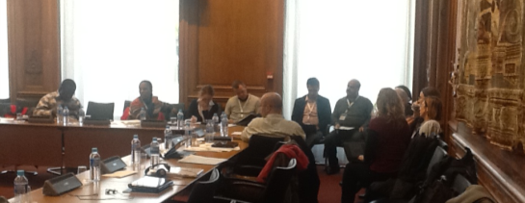
More emphasis on the South is a good approach. It is important to have a clear view on all the activities of the network. An increased participation of the South is important, a hands-on approach that is demand led. The three pillars (south, advocacy and overall coordination of the network) are well chosen. A better balance and coordination between north and south for the coming four years is needed. The role of the regional offices is important. No need to create new or parallel structures; we should strengthen and use what already exists. South-south cooperation is a good concept that has to be used.
Report of the Spanish working group
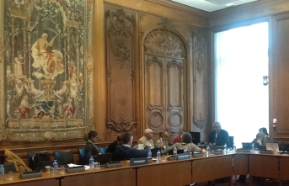
Full agreement with the general objectives: strengthening of the network, strengthening of the organisations, and awareness raising. We need a debate on the participation of the GUFs in the network. We like to maintain the General Meetings and the FSG. Methodology is important, policy work is also important.
Report of the French working group
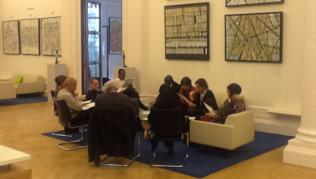
The plan receives full support. The role of the regional organisations in Objective 1 is important. They have a role to play for organising and coordination.
How representative are the trade unions in the south in the informal economy? The informal economy is certainly for Africa a priority. We must find a balance between north and south regarding the advocacy work.
Debate
The new framework proposal clearly corresponds with the views of the different working groups so that we can continue on the suggested lines. There is also agreement on the capacity development in the south, with emphasis on the ownership of this capacity development. The local organisation sits in “the driver’s seat”.
Regarding the participation in meetings, the right people should be present … A pro-active calendar of activities from Brussels and the organisations would be useful.
South-South cooperation is of growing importance: South Africa with Mozambique; CUT Brazil with Portuguese speaking countries in Africa. How can we make this more visible in the work of the network?
Closure of the meeting
Maurice concludes the meeting and indicates that the debate continues, although the major lines are now clearly confirmed. He thanks all the participants for the open debate, with space for concerns and questions from everyone.
Jan thanks the French trade unions for their hospitality, for the opportunity to participate in a manifestation yesterday, for the introduction in the secrets of the French gastronomy.
He thanks the members of the General Meeting for the decisions and the approval of the future program. He hopes that the European Commission will support the program with the necessary funding. He also thanks Kasia whose contract will end at the end of December. She was responsible for the newsletter, for the database, the visibility of the network, the questions around the millennium development goals and beyond 2015, around education and development.
The next General Meeting will take place in Denmark, in the week of 15 to 19 April 2013.

