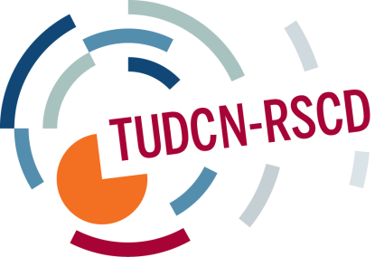

TRADE UNION DEVELOPMENT COOPERATION NETWORK
CALENDAR OF ACTIVITIES 2014-2015
2014
22nd of May, Berlin | ITUC congress side event on development cooperation and TUDCN
28-29 August, San Jose (Costa Rica) | LA regional development network meeting – Evaluation of trade union development cooperation in Central America and the Caribbean (focus on partnerships)
29-30 September, Brussels | Open Coordination Meeting (OCM - former FSG – Back-to-back with the EU PFD)
6-10 October, Lome CANCELLED | African development network meeting (focus on advocacy)
29-30 October, Paris | Seminar: trade union meeting with DAC on global agendas
20-21 November, Lome  CANCELLED | African regional development network meeting (focus on partnerships)
2-5 December (tbc), AP | AP regional development network meeting (focus on advocacy/partnerships)
2015
February | LA regional development network meeting (focus on advocacy)
February | Thematic seminar: OCA (organizational capacity assessment) frameworks
March, Lome | TUDCN General Meeting
April | Thematic seminar on: global governance and Financing for Development
September, Lome | African development network meeting (focus on advocacy)
November | African regional development network meeting (focus on partnerships)
December | AP regional development network meeting (focus on partnerships
tbc | Open Coordination meeting (back-to-back with the EU PFD)

