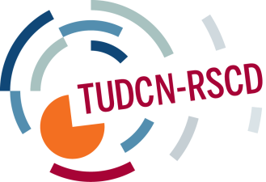

TRADE UNION DEVELOPMENT COOPERATION NETWORK
GENERAL MEETING

Sao Paulo, 18th -20th March 2014

Tuesday 18th of March

The General Meeting was opened by Victor Baez (General Secretary of the TUCA) and Wellington Chibebe (Deputy General Secretary of the ITUC) who highlighted the importance of this first meeting on development cooperation in the Global South.

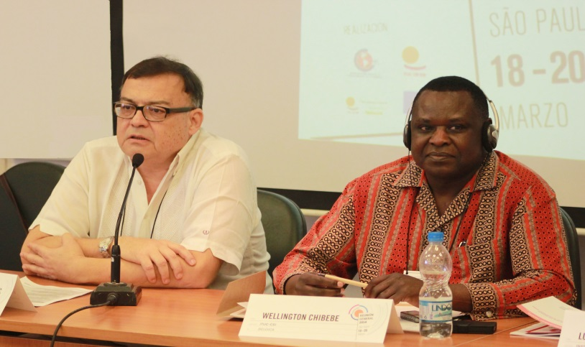
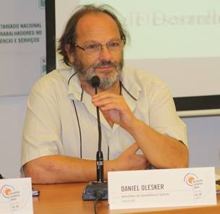
Daniel Olesker
Minister of Social Development of Uruguay

He exposed the development model of Uruguay
“Economic growth needs to be accompanied by redistribution policies to bring development”

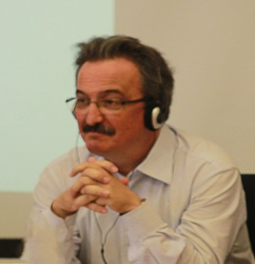
Luiz Dulci
Director of the Lula Institute

“Today, Latin American governments do not have a common ideology or strategy of change. This is our biggest challenge”
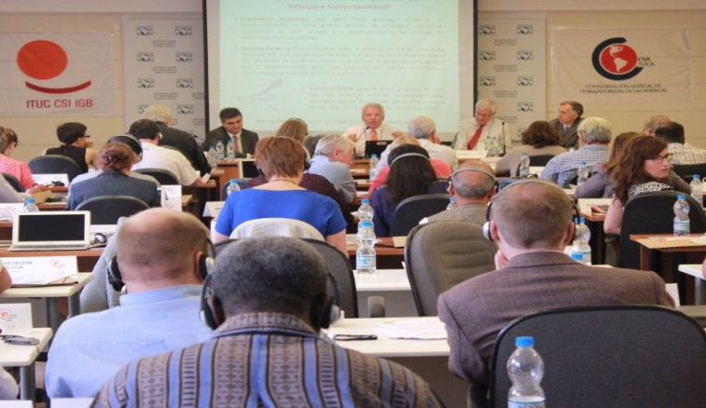

Boris Utria
Country operations advisor of the World Bank in Brazil
He made a presentation on the evolution of the World Bank and its approach to development throughout the years.

Carlos Mussi
Director of CEPAL Brazil
He made a regional analysis of the present economic and social situation in Latin America and indicated future challenges.

Pedro Santos
European Commission delegation in Brazil
He gave a brief outlook on the European Commission’s perspective and agenda with respect to development cooperation.

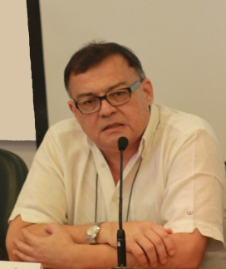
Victor Báez
Secretary General of TUCA

He exposed the creation and objectives of the
PLADA - Development Platform for the Americas

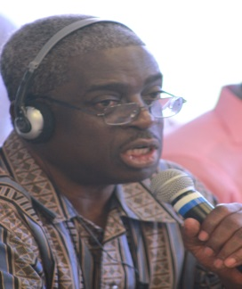
Kwasi Adu-Amankwah
Secretary General of ITUC Africa

He mentioned the consequences of the IMF and World Bank policies in Africa and the role of trade unions in development.

Working groups then discussed the trade union development model.

The main conclusions were:

- Trade unions want a stronger role for the state. In Latin America, the State has an increasing regulatory capacity, whereas this capacity is being lessened in Europe.

- The international financial system has to be regulated. Trade unions demand an end to corporate driven governance.

- Trade unions want quality and publically-owned public services (free and quality education, healthcare, etc.)

- The private sector needs a stricter framework; tax systems should be fair; policies should be based on decent work and a human-rights based approach to development.

Wednesday 19th March

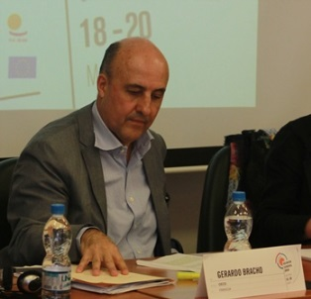
Gerardo Bracho
Senior Policy Advisor, Development Cooperation Directorate of the OECD

He introduced the current situation and the debates in view of the 1st Ministerial meeting on Development Effectiveness to be held in Mexico in April.

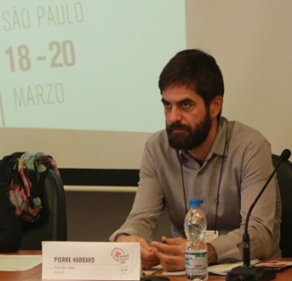
Pierre Habbard
Trade Union Advisory Committee to the OECD / ITUC

He presented the draft position paper on the private sector in development, outlining the different roles that it plays and the increase of official development assistance allocated to this sector. He concluded with policy priorities for trade unions.

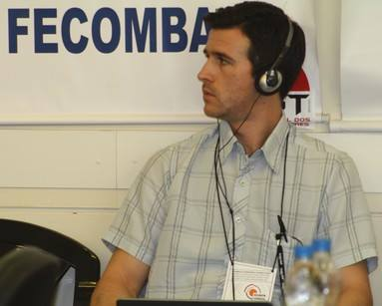
Matt Simonds
International Trade Union Confederation

He introduced the debates on the post 2015 agenda, focusing on the Open Working Group and the current focus areas.
He emphasised that the final decision will be made by the UN General Assembly in September 2014.

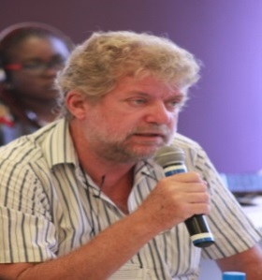
Kjeld Jakobsen
Trade Union Confederation of the Americas

He gave an overview of the situation concerning South-South and triangular cooperation in Latin America.
He emphasised the lack of strategies and legal framework for this kind of cooperation, in which labour related themes are often absent.

The debates of the afternoon session were organised in working groups in which the four subjects treated in the morning presentations were discussed.

The main conclusions of the different working groups were:

- In terms of the high level meeting in Mexico, trade unions need to focus on few objectives: taxation floors, accountability and transparency, including in contracts with multinational companies.

- A stronger private sector might contribute to growth but not to wealth redistribution. Trade unions thus question the legitimacy of the private sector as a beneficiary of cooperation policies and the role of the private sector as a donor. Standards and criteria have to be set for all the companies who want to take part in development cooperation.

- In the post-2015 process, our main advocacy message should be the support for a global governance framework which includes rights and provides accountability.

- In terms of south-south and triangular cooperation, new emerging economies should obey to the same development effectiveness rules and criteria as other donors.

Thursday 20th March
The third day, chaired by Maurice Bossuat (CFDT), started with presentations of activities in the regional organisations of the ITUC in Latin America, Africa, Middle East North Africa and Asia-Pacific.

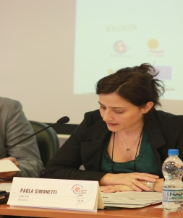
Paola Simonetti (ITUC/TUDCN) presented the TUDCN report of activities and results for 2013-2014 and the action plan for 2014-2015, as well as strategy documents.

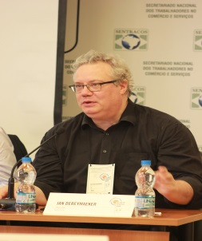
Jan Dereymaeker (ITUC/TUDCN) discussed improved governance mechanisms which were endorsed by the audience.

The chair concluded the work and thanked the TUCA leadership and staff for hosting the meeting as well as the rest of the team for the excellent conditions of work and for their hospitality.

