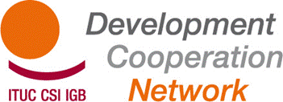

TUDCN Workshop on Development Education

“Towards a shared Trade Union programme”
September 12-13, 2013
Centro Studi CISL
Firenze, Italy

WORKSHOP REPORT

Contents
Participants 2
Opening session 2
Session 1: BACKGROUND & EXPECTATIONS 3
Session 2: European Commission on DEAR programme 4
Session 3: ANALYSIS & UNDERSTANDING 4
Session 4: IDENTIFYING STRATEGIES - Framework of the Programme 6
Session 5: PROGRAMME ARCHITECTURE & GOVERNANCE 8
Session 6: WAY FORWARD 9

Participants
SPAIN | ISCOD UGT | Javier | Vaquero
SPAIN | USO | Santiago | Gonzalez Vallejo
CYPRUS | DEOK | Flora | Giagkou
ITALY | ISCOS | Gemma | Arpaia
ITALY | ISCOS | Elisa | Bucchi
ITALY | ISCOS | Vincenzo | Russo
ITALY | CGIL | Rita | Tassoni
ITALY | CGIL | Sergio | Bassoli
HOLLAND | CNV | Eugène | Litamahuputty
HOLLAND | CNV | Klaaske | Zwart
HOLLAND | FNV | Mario | Van de Luijtgaarden
BELGIUM | ABVV/FGTB | Thierry | Aerts
BELGIUM | CSC/SM | Arnaud | Gorgemans
IRELAND | ICTU | Fiona | Dunne
SWEDEN | LO-TCO | Carina | Söderbjörn
ROMANIA | Cartel Alfa | Catalin | Toscuta
ROMANIA | BNS | Mariana | Kniesner
FINLAND | SASK | Jukka | Pääkkönen
SouthResearch | Bob | Peeters
ITUC | Jan | Dereymaeker
ITUC | Paola | Simonetti

Opening session

Development Education (DE) is a familiar theme to the TUDCN since an important number of its members run national development education programmes. Also a specific seminar has been already organised last year in Vienna. While the seminar in Vienna was aimed at information and best practices exchanges among TUs on DE initiatives, the current workshops is shaped on an operational and forward looking fashion, being instrumental to respond jointly to the future call for proposal of the European Commission (DEAR programme).
A common will to support this initiative is of course a prerequisite to move forward. Therefore a primary aim of the workshop will be to assess the interest of participating organisation in getting on board, trying to jointly shaping the objectives, contents and finally the operational management modalities of the future programme proposal.
The added value of a possible joint programme on DE is:
- Reinforce critical engagement and active participation on global development paradigms within TUs
- Share a common framework conceived on common objectives and approaches within the European TUs
- Increase impact of international solidarity initiatives of TUs based on common strategies
- Allow the TUs to meet with the minimum requirements on participation and scope of the EU CfP (min 10 countries involved and budget between 3 and 5 million € on 3 years)
The seminar was facilitated in an interactive mode with the help of Bob Peeters from South Research, an agency specialised in planning, monitoring and evaluation methodologies.
The first day was focused on brainstorming on the relevance, the objectives, target groups, results and strategies we want to achieve, while during the second day we also touched upon the operational features and management arrangements of the would be joint programme.
Finally, practical follow up steps and deadlines were set.

Session 1: BACKGROUND & EXPECTATIONS

Participants, divided in 3 WGs, were asked to highlight major themes dealt with and positive experiences experimented in the context of DE initiatives at national level.
Main issues raised:
- DE used to mobilise workers on global development, through collective bargaining agreements – CBA clauses supporting international solidarity projects;
- Exposure visits in Europe at TUs and enterprise level: testimonials from the developing countries trade unions on working conditions and labour related topics;
- Awareness Raising within multinationals – supply chains and framework agreements
- Coalitions/campaigns of TUs together with other CSOs on decent work (see Belgian case);
- Campaigns on social protection;
- Consumers campaigns to support ethical consuming and raise awareness on working conditions in the countries of origin;
- Campaigns to support 0.7% commitment on ODA;
- DE initiatives reinforced the link between lobbying, fund raising, education and visibility;
- DE initiatives support TUs unity of action at national level
Subsequently, participants highlighted major opportunities and challenges on the would-be joint programme on DE. Main issues raised:
OPPORTUNITIES | CHALLENGES
Shared communication strategies/joint  campaigns on common themes: stronger  mobilization across Europe and policy  influence | Different national contexts and approaches  when it comes to activities  implementation  – different internal priorities
Wider and stronger partnerships amongst  trade unions | General economic crisis & decreasing TUs  affiliations in the EU
Reinforce the work of the TUDCN, taking the  advantage of a strong network | Complexity of programme  management and governance
Improving the quality & impact of DE

Session 2: European Commission on DEAR programme

See Markus Pirchner ppt: http://www.ituc-csi.org/documents-from-the-meeting-13711
Main points:
- The two approaches on ‘development education’ and ‘awareness raising/campaigning’ are not mutually exclusive: the EC doesn’t mind the mix!
- However the programme should describe clearly what is the priority approach chosen (DE or AR) describing the complementarity between them
- Development Education approach: process oriented, targeting a more selected type of beneficiaries
- Awareness raising/campaigning approach: results oriented (such as exhibitions), targeting wider public
- Highlighted the ‘interesting’ role of TUs within international private sector companies

Session 3: ANALYSIS & UNDERSTANDING

In order to define the objectives of the future programme participants carried out a ‘context analysis’, to get the wider picture in terms of problems to be addressed, stakeholders to be targeted, and themes/contents to deepen. Three methodologies were used respectively in 3 different working groups (WGs):
- Stakeholders analysis (WG 1)
- Problem Tree (WG 2)
- Mind Mapping (WG 3)
Results of the WG 1:
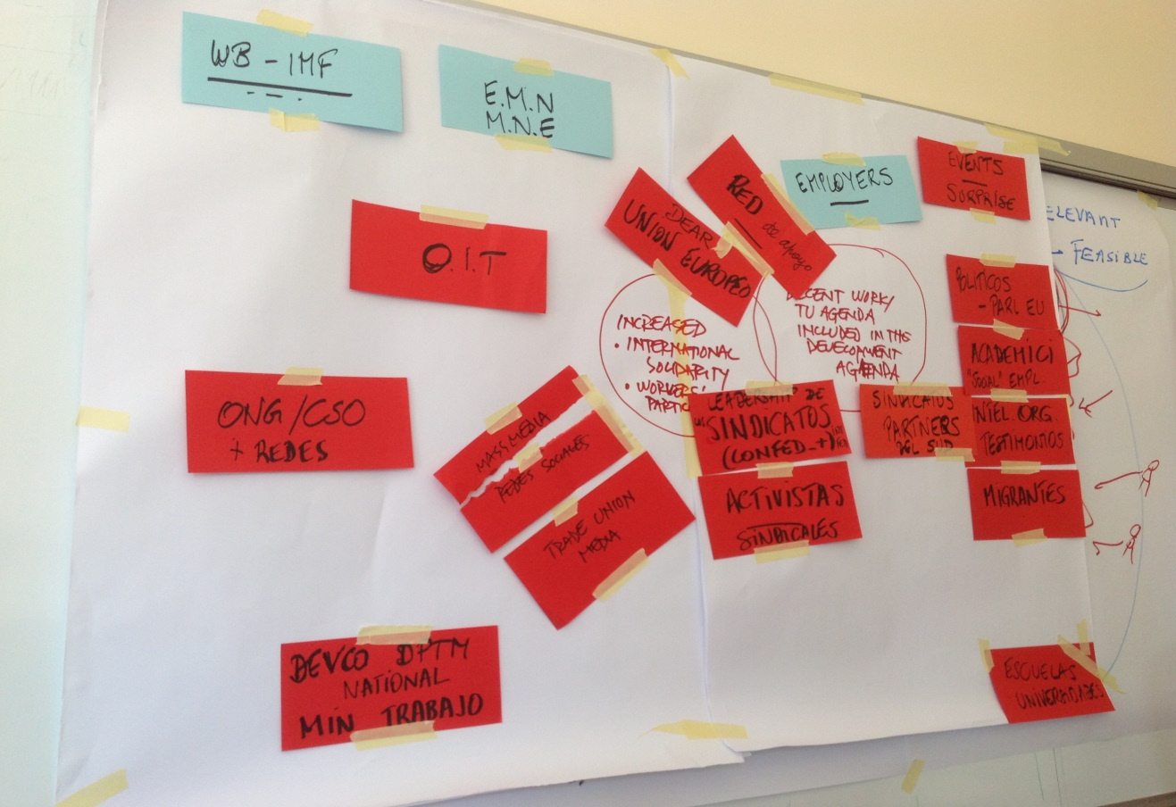
Participants were asked to spot relevant typologies of actors that could influence negatively or positively the success of the program. The latter has been identified with: “decent work agenda included in the development agenda” and “increased international solidarity and workers participation”. The closest the actor is to the centre, the more influential it is (RED: positive influence; BLUE: negative influence).
It emerged that trade unions and their activists are the first category highlighted, followed by politicians, academia, migrants, mass media etc...
Results of the WG 2:
Particpants were asked to spot problems and their causes, allining them in causality order. The work started from the failure of achieving decent work for all and it trickled down to majour causes such as:
- Global economic crises undercutting social contracts and fundamental rights
- Employers not engaging any more in social dialogue with TUs, with the consequence lack of trust
- People/societies tend to become more and more individualistic, losing the value of collective actions and solidarity
- Politics and politicians / governments approaches are often prioritizing only economic growth and are not values oriented
- The decent work concept is still not known and the work of TUs at international level is also ignored by the decision making actors and sometimes within the TUs organisations themselves
Results of the WG 3:
Here participants put at the centre ‘decent work and workers empowerment’ highlighting the need for increased capacity of TUs in advocacy and lobbying on development issues
Following the WGs results report, a plenary discussion took place, already delineating key features for the programme:
- Contents: decent work agenda and a new paradigm for global development based on rights, work and dignity. The current post 2015/SDGs processes are key point of reference;
- Targets: trade union organisations and their activists should be primarily addressed to promote the new agenda for development at national level. Their knowledge and capacity should be strengthen as well as communication skills and tools improved
- Methodology: common campaigns can be run in each country involved in the programme, each year on specific theme jointly selected

Session 4: IDENTIFYING STRATEGIES - Framework of the Programme

On the basis of the results of the analysis the first day, the following proposal for a TUs global solidarity programme was drafted and discussed:
Overall Objective
“Promote and ensure implementation of the decent work agenda in development strategies in
Europe”

The focus of the programme will be on national level action in coherence with but not
duplicating the broader TUDCN programme (namely obj. 2)

Specific Objective 1
To contribute to awareness-raising of TUs members and leaders on the need for an
alternative development model (DWA). This will demand a new narrative (vision). Target group in the programme: TUs Members and leaders
Specific Objective 2
To strengthen advocacy towards national government (and EU) on rights at work, decent job
creation and living wages, social protection and social dialogue.

Target group in the programme: national & European institutions

Specific Objective 3
To improve the effectiveness of TUs approaches and actions in development cooperation/
education

Target groups in the programme: practitioners, members of the TUNGS (Trade Union Network
For Global Solidarity)

Feedbacks form participants on objectives and potential activities:
This programme is understood to be complementary and reinforce to national actions on DEVED and to the TUDCN (link with EU WG and TT on post 2015). The focus is primarily on national action plans for awareness raising (obj. 1) and advocacy on DWA in development (obj. 2); it also wants to promote the common approach by organisations word.
National action plans should include baseline on both objectives (baseline need a common approach). There should be agreed (common) list of eligible themes/priorities for campaigns:
Year 1 DWA Issue 1
Year 2 DWA Issue 2 (European Year of Development)
Year 3 DWA Issue 3

Objective 1:
- Drafting a new ‘narrative’ on global development to raise awareness within TUs, instrumental for advocacy as well
- Curricula on global development models within TUs training programmes
- CBAs in companies to support cooperation programmes
- Internal TUs Newspapers, communications tools etc…
- Public statements of TUs leaders supporting development priorities
- Awareness Raising within multinational companies (developing common materials, campaigns for TUs sector federations)
- New Member States: putting development in the PERC agenda

Objective 2:
- Monitoring national development policies on DW promotion (drafting reports, survey)
- Addressing politicians with policy statements
- Participating in governmental negotiations/consultations on development policies
- Suggestions for common campaigns themes: rights at work; living wages; social protection; taxation. Possible activities: documentaries/video clips/media involvement
- Building alliances with other CSOs
- Campaigns in connection to focal events at EU and/or international levels
- Organising ad hoc events on May 1 and October 7 for wider public

Objective 3:
- Sharing and coordination of the national action programmes to improve effectiveness in trade union development education

Session 5: PROGRAMME ARCHITECTURE & GOVERNANCE
National Level
- A ‘steering group’ should be set up made by min 1 representative by each organisationinvolved and is responsible for the elaboration and drafting of the national action plan;
- The steering group is also responsible for monitoring and reporting on results achieved and activities implementation;
- An official protocol of agreement should be signed by each organisation involved in the programme with the ITUC;
European Level
- A ‘steering committee’ at European level should be set up with the aim of: providing contents support for planning (2 meeting a year for ex.) and monitoring the programme implementation
- This steering committee should be made by ITUC secretariat + ETUC secretariat + 1 national representative per country;
- Programme partners meetings: 1 a year aimed at decision making and reporting
Budget issues
General Budget features
- National Actions Plans = 4,5 million € for 3 years
- European Level coordination/operations + New Member States support = 1,3 million €
Budget allocation criteria at national level
- The budget should be channelled to each individual organisation
- The budget amount should be determined considering: 1) weight of representation of national organisations (size of organisations); and 2) quality of national action plans
- Staff costs should be limited to a maximum %
Own contribution
15 % is the co-financing rate from the applicant. The same % can be applied to partner organisations. Alternatively the difference between co-financing and administrative costs (15%-7% = 8%) can be applied.

Session 6: WAY FORWARD
For those organisations that are not yet register in PADOR, please do it URGENTLY! This is the pre-condition for eligibility in European projects:
http://ec.europa.eu/europeaid/work/onlineservices/pador/
Timeline
Secretariat
National organisations
The response of the Commission on the concept note is expected by 1/01/2014 (tbc). If successful, the full program proposal should be submitted in the first quarter of 2014.
In the meanwhile, the following things should be carried out:
- Further elaborate the framework
- Elaborate the national action plans by partners
- Agree on shared actions and action plan
- Formalise an agreement on financial arrangements: MoU with partners spelling out content, management criteria and commitments

Brussels, 30/09/13

