REPORT ON THE CELEBRATION OF THE EVENT DEDICATED TO THE WORLD DAY FOR DECENT WORK, 7 OCTOBER 2016

Event: Workshop
Topic: "Decent Work"
Organizer: Federation of Trade Unions of Macedonia (ССМ)
Date: 7.10.2016

REPORT
ССМ HAS MARKED 7 OCTOBER, THE WORLD DAY FOR DECENT WORK
7.10.2016
Today in the premises of the Federation of Trade Unions of Macedonia (CCM), a workshop titled "Decent Work" was organized as well as a Press Release to the Media was sent regarding the celebration of October 7, the "World Day for Decent Work."
Attendees on this event, besides the leadership of the Federation of Trade Unions of Macedonia, the President of CCM, PhD Zhivko Mitrevski and the Secretary of the Council of CCM, Metodija Dimeski, were present the regional trade union coordinators and staff of the regional trade union offices and subsidiaries of CCM.
The main objective of the workshop was to promote the importance of the decent work program signed in Macedonia for the period 2015-2020 year, its policies, efforts and activities of the Federation of Trade Unions of Macedonia. In this regard the Law on peaceful resolution of labor disputes was presented and discussed as a law arising from the obligations stipulated in the decent work program.
The workshop was opened by the President of the Federation of Trade Unions of Macedonia, PhD Zhivko Mitrevski, who pointed out the importance of this day and underlined the campaigns being conducted at the level of the International Trade Union Confederation (ITUC). He also stressed the idea from where the concept of decent work has been derived, emphasizing that: "The trade unions are determined to fight for the values ​​of labor, to follow the trend of exercise and increase of workers' rights in accordance with the established standards recognized in the world" .
At the first session of the workshop, Mrs. Lile Petrova, a lawyer in the Legal department at CCM, gave a brief overview of the main topics covered by the Decent Work Program and pointed out the obligations arising from this program which are in a direct correlation with the working obligations of the Regional TU Coordinators.
The second session of this event was opened by Mrs. Lidija Naskovska, Advisor to the President on Projects and EU integration, and also a licensed arbiter/ conciliator for labor disputes by the Ministry of Labor and Social Policy of the Republic Macedonia who presented the Law on peaceful settlement of labor disputes. With the latest amendments, this law is fully implemented in Macedonia having an effective mechanism for resolving collective and individual labor disputes outside court. The main task of the regional trade union coordinators is to provide free legal assistance. By that this law opens the way for a faster resolution of these disputes.
The end of the workshop was devoted to a fruitful discussion in which participants discussed on certain specific problems facing on field and different possibilities to resolve them in this way.
In addition you can find the Announcement/ Press Release that was sent to the media on 7.10.2016:

PRESS RELEASE
7.10.2016
The Federation of Trade Unions of Macedonia this year shall actively be involved in mobilizing to mark the World Day for Decent Work. Starting from 2010 and all these years, the concept of decent work which CCM celebrates and promotes is a concept that is associated with the requirements for ensuring and promotion of social security, secure jobs, lower poverty rates, equal opportunities and work for all without discrimination of any kind, development of the social dialogue and participation of trade unions in the policies and decision-making on issues relevant to the workers.
Today, faced with the economic crisis and the threat of globalization of capital, corporate greed of companies and unequal distribution of profits, we shall mobilize our members to exercise the right of collective bargaining and trade union organizing in order acquire secure jobs and decent wages, social protection of all, exercise of the fundamental human rights, democracy and social justice, safe conditions at work, protection of certain categories of workers, women, disabled people and a healthy environment. CCM and this year shall be working in a devoted manner to implement in full the National Program for Decent Work 2015-2020.
This day we celebrate with several activities, promotions, posters, seminars and round tables devoted to the significant meaning of the World Day of Decent Work.
The President of CCM, PhD Zhivko Mitrevski on the occasion of 7th October, the World Day of Decent Work emphasized that decent work must be based among other things on the belief that every modern society should provide new employment, social progress and development, a dignified life, equal treatment and equal opportunities for all, productive work and personal life and social development followed by a dignified paid work and social and material existence.
___________________________________________________________________________

Explanatory Note on the Decent work concept
The idea and the concept of decent work arise from the International Labor Organization, promoted in 1999, on the 87the International Labor Conference. It is based on the understanding that work is a source of personal dignity, democracy and general economic growth in the community. Decent work is a key element for achieving fair globalization and poverty reduction.
The idea of ​​decent work is accepted at the World Summit of the United Nations in 2005, followed by the Economic and Social Council of the United Nations (ECOSOC) in 2006, and on the World Social Forum held in Nairobi, the campaign "Decent Work, dignified life" (2007) was launched and 7th of October was declared as the World day for decent work.
The celebration of this day is widely accepted by the Federation of Trade Unions of Macedonia. In doing so, CCM has become part of the global campaign to protect and promote the economic and social situation of the workers and the implementation and promotion of workers' rights for a decent work.

Federation of Trade Unions of Macedonia

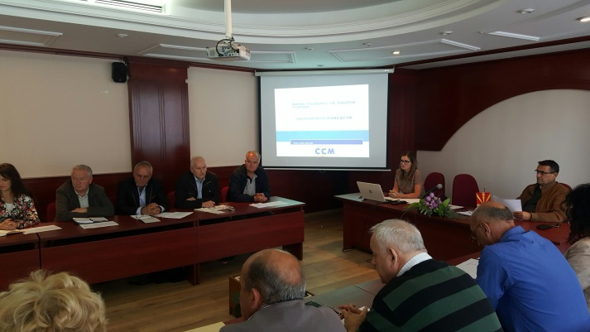
Photos from the event:
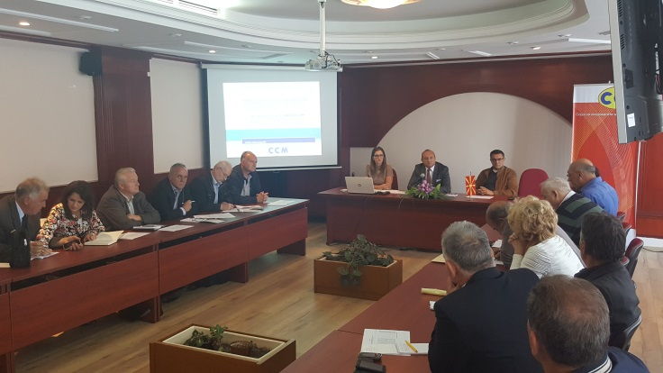
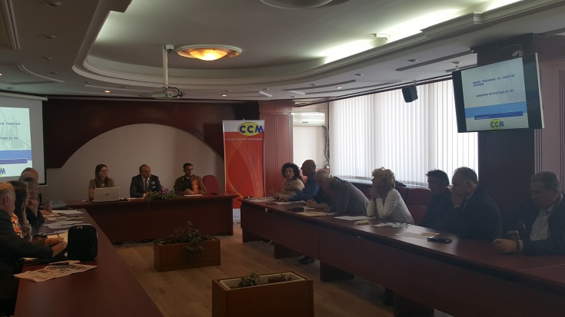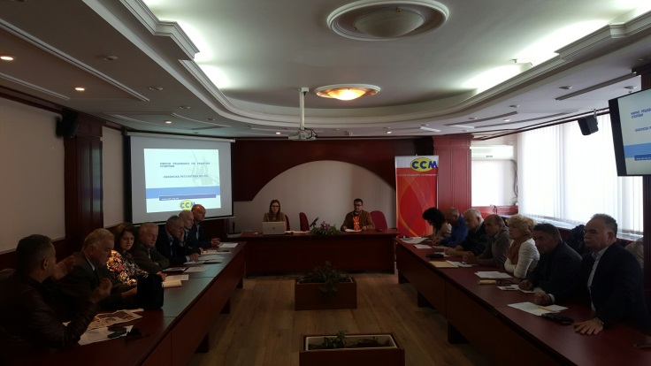
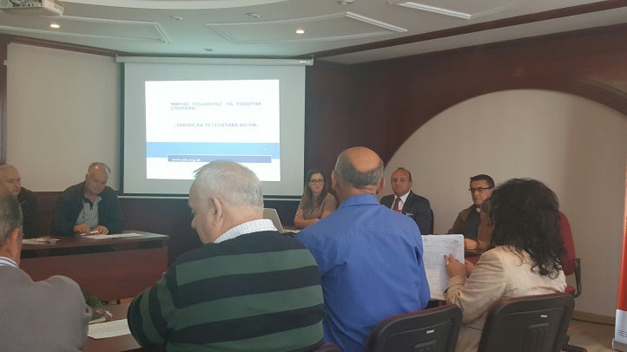
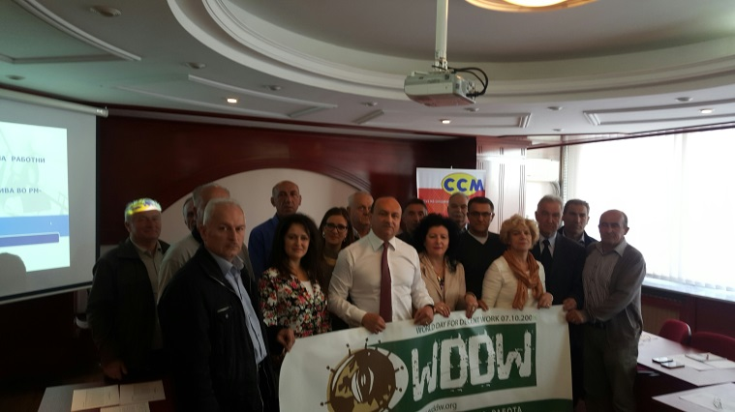
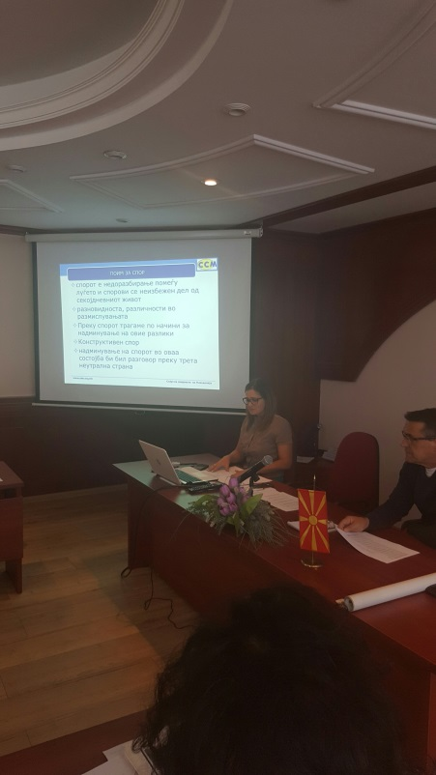
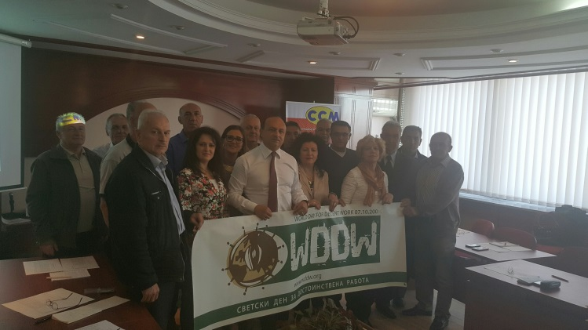

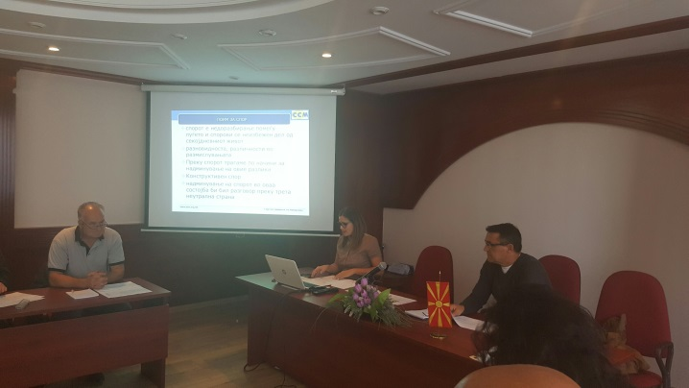

Media:
http://tera.mk/ssm-ke-go-odbelezhi-svetskiot-den-na-pristojnata-rabota/
http://sitel.com.mk/ssm-kje-go-odbelezhi-svetskiot-den-na-pristojnata-rabota
http://telegraf.mk/aktuelno/makedonija/ns-newsarticle-ssm-odbelezuvane-na-svetskiot-den-na-pristojnata-rabota.nspx
http://lider.mk/2016/10/07/ssm-%D1%9Ce-go-odbelezi-svetskiot-den-na-pristojnata-rabota/
http://a1on.mk/wordpress/archives/653704
http://netpress.com.mk/ssm-go-odblezuva-svetskiot-den-na-pristojna-rabota/
http://www.press24.mk/ssm-kje-go-odbelezhi-svetskiot-den-na-pristojnata-rabota

Poster:
