Open Coordination Meeting
29-30 September 2014, Brussels

Monday 29 of September
TUDCN UPDATES SINCE SÃO PAULO AND GOVERNANCE ISSUES
- Follow up of the ITUC Congress: conclusions of the sub plenary and ITUC work plan for the future (see Congress report)
Wellington Chibebe, ITUC DSG, presented the conclusions of the sub plenary on development cooperation during the ITUC Congress and draw the attention to the implementation of the action plan, to be discussed by the General Council in December 2014. He also stressed the successful events organised at the congress and highlighted the continuity in the work of the TUDCN, implementing the 2006 and 2010 ITUC Congress resolutions.

The TUDCN secretariat will ensure coherence between ITUC priorities (Supply Chains, Minimum Wages & Informal Economy, Eliminating Slavery and Climate Justice) and the TUDCN strategic framework.
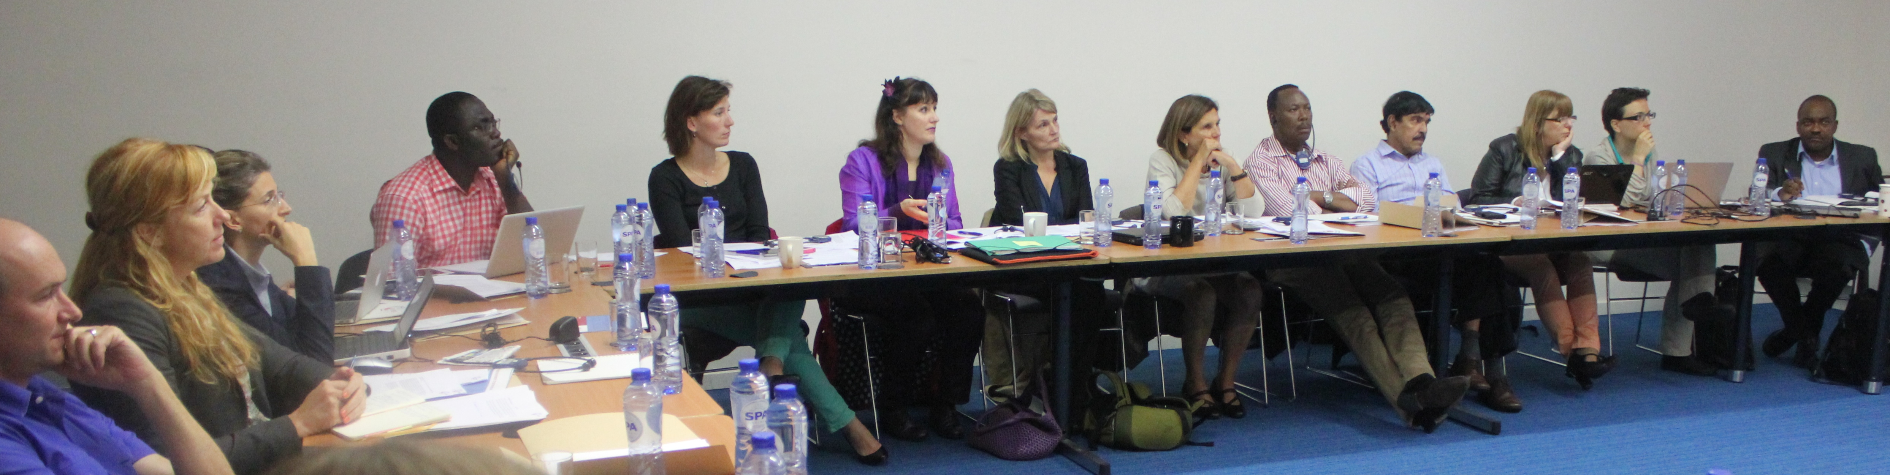
- Open Coordination Meetings and Steering Group composition (see report GM in Sao Paulo)
Following the decisions in Sao Paulo, the Open Coordination Meeting, open to all interested organisations will ensure coordination in between the annual General Meeting. Participation of regional reps to the OCM will be ensured by the TUDCN. A small Steering Group (1 per continent and 1 GUF), will assist the secretariat with the implementation of the workplan.
As proposed, the Steering Group will be composed of the organisations that participate in the Policy Forum (two representatives from the European Trade Unions, one from Africa, and one from Asia and one from Latin America) plus one representative from the GUFs.

- TUDCN working groups
5 working groups will be put in place: Global policies; EU; partnerships; development education and south-south coop). The coordination of all working groups will be ensured by the TUDCN secretariat, except for the South-South working group that will be co-coordinated by TUCA.
The TUDCN secretariat look at the working methods /operational system for the working groups, especially in terms of languages as English cannot be the sole working language. Information on the workgroups will be send to the whole network.
- Global Unions Meeting on Development
The TUDCN is interested in coordinating efforts with TUSSOs for LFA trainings.
IndustriAll is planning a training seminar on the Logical Framework Approach (LFA) with LO TCO in Johannesburg for Industriall project coordinators. Another training will be organised in Singapore with BWI and Industriall project coordinators.
The relevance of the Logical Framework Approach was discussed, especially in comparison with methodologies based on Outcome Mapping. Donors use different models and we may want to organise capacity building on the various approaches.
- TUDCN Communication and information strategy
Feedback was received on the communication activities so far: newsletter, publications, video and social media. Proposal for an ‘alert’ system has been suggested to notify news on the web site to the TUDCN members. The database will be updated, and regular calls for inputs will be sent by the secretariat to TUDCN members.
The TUDCN and national organisations communication strategies need to be mutually reinforcing. A network of trade union communicators on development could be created to this end.
Equal Times is also a good vehicle to share views and opinions on development from a trade union perspective.
The “activities report” and the TUDCN video were well received.
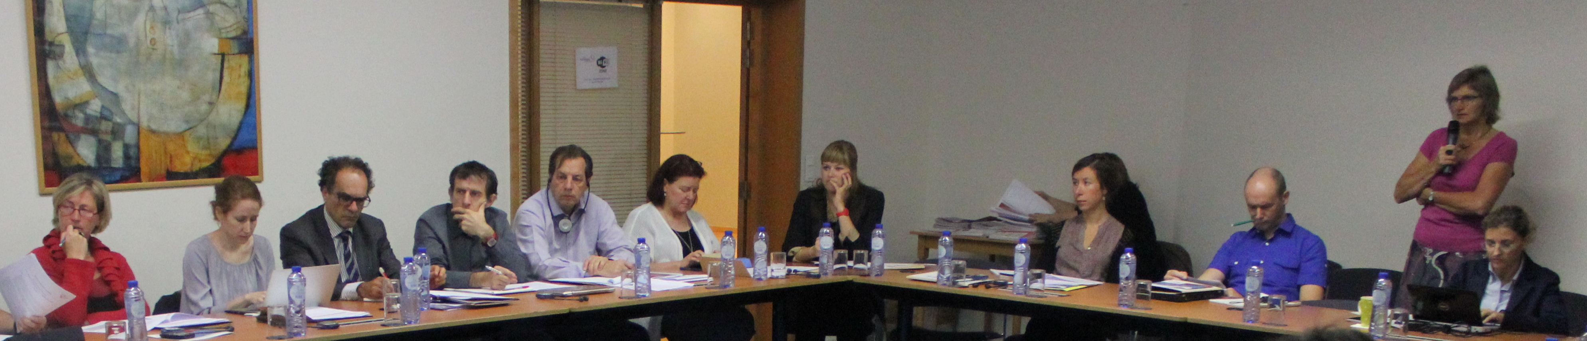
TRADE UNION ADVOCACY ON DEVELOPMENT
- United Nations

- Post 2015: the Sustainable Development Goals
Claude AKPOKAVIE, from ILO-ACTRAV, gave an overview of the ACTRAV workshop on post-2015 last June. The workshop ended with a set of recommendations which were communicated to the ambassadors of the co-chairs of the open working group in New York and Geneva.
The outcome document of the Open Working Group will serve as the basis for the negotiations on Sustainable Development Goals (SDGs), along with a report from the Secretary General. At the end of 2015, a meeting of heads of government should endorse the SDGs.
There seems to be a wide consensus to keep decent work as an explicit goal but trade unions should now also concentrate on the targets associated with decent work and the indicators to measure those targets. Furthermore, the goal on governance should be reinforced, including social governance issues such as social dialogue.
Themes missing from the current goals:
- social dialogue
- inequality
- labour market institutions
National work is of utmost importance at this stage. National delegations are the most influential actors in the discussions now and they are usually made of employees from Ministers of Foreign Affairs who know little about labour issues. The TUDCN secretariat will inform members about the key moments to send advocacy letters and will draw a mapping of government positions on labour demands (ex: decent work, social protection, inequality).
Possibilities will be also explored with ACTRAV to work specifically on targets and indicators so to corrobarate futher the negotiations.
- Financing for Development
The Financing for Development process started in 2002 in Monterrey around taxation, Foreign Direct Investment, trade, policy coherence, debt and other systemic issues. A follow up conference took place in Doha in 2010. Unfortunately, there has not been much political leverage since around these themes. The current SDG discussion however has triggered a new interest in FfD and a FfD-conference is called for to take place in July 2015 in Addis Ababa. Trade unions will need to reflect on policy strategies on the whole theme, and address participation modalities for Addis Ababa.

- OECD/DAC: review of ODA
The OECD- DAC (Development Assistance Committee) is currently looking at the definition of aid as part of an OECD debate framed as the “modernisation” of ODA.
Trade unions do not have a position on this issue but have relied so far on the research of Eurodad on that matter. The Paris seminar (October 29) will address this issue in details.
- OECD-DAC seminar with TUDCN on private sector in development
On 30th October, Representatives of DAC member countries will meet Trade Unions:
- to initiate a more systematic engagement between DAC and trade unions
- to bring the trade union development agenda (decent work) to the DAC table
- to present alternative development models (ex: Bolsa Familia in Brazil) to DAC delegates.

- The CSO Partnership for Development Effectiveness CPDE
The Partnership was established to follow the negotiations of the Global Partnership for Development Effectiveness.
CPDE is relevant to the work of TUDCN as a channel for TUs to influence other CSOs on their political priorities Trade unions have put a lot of work into preparing positions on various development issues for meetings related to the Global Partnership. This work has been recognised and valued by other constituencies of the CPDE.

Tuesday 30 September
- EU financing for Trade Unions: future approach
Feedback on the rejection of the project proposals to the EU:
- Development Education: the proposal was technically good, but the ‘hegemony’ of NGOs is still strong. The TUDCN should increase visibility of TUs activities in the development education field. The secretariat will produce a publication (collecting examples of TUs programmes) for wider dissemination both at EU and national level. In parallel, the secretariat will keep raising the issue with EC officials. The plan is to submit again a proposal in 2015, on the basis of the orientations of the network members.
- Informal economy: our proposal was not ideal from the technical point of view, and this has to be improved. On the other hand, the EC itself has a policy approach which is not based on ‘rights’ promotion but still rather on ‘services’ provision re informal economy. Actually this is true for the whole ‘global public goods’ program, where social dialogue does not find enough political support from within the EC. This affects directly the perception of TUs as important actors to be supported. Therefore, the secretariat will keep liaising with the EC officials to advocacy the importance of social dialogue in development. In this respect, the research plan on social dialogue (see below) will be proposed.
Some recommendations were provided by participants to improve future funding proposals by trade unions:
- Collect more data from project implementers and adapt trade union language to the funders’ language, despite the fact that funders do not seem to understand the reality on the ground in the South or social dialogue.
- Anticipate call for proposals. Start working on them before they are open.
- Build relationships with funders for better chances of success and to receive early warnings on future calls.
- To work on the human rights budget line of the EU. For this particular issue, the secretariat highlighted that it should increase its capacity (in terms of human resources) in order to be able to enlarge the scope of the work. Increased capacity will result also in better coherence amongst trade unions themselves and within the ITUC, and therefore organisations are invited to raise this point also in the GC of the ITUC.

- TUDCN plan of action
For the moment, meetings in West Africa are postponed and alternatives are being considered.
- Global Action Plan:

- Post 2015
Before the end of 2015, TUDCN and ILO ACTRAV will try to organise an expert meeting to study indicators for the post 2015 framework & to develop better more concrete advocacy proposals.
- HRBA and Private Sector
The TUDCN will be in charge of developing a study (in the context of the CPDE) on how to increase the accountability of multinational companies when they receive public money for development projects. The outcome will be an advocacy tool for the whole of TUs and CSOs. See Terms of reference on the web site.

- Global Governance
The TUDCN should define a position on global governance. This will need to be conceived in coordination with ACTRAV and also with other prominent CSOs. To this end a ‘brainstorming’ seminar will be organised in 2015. See background note on the web site.
- Social Dialogue for Development
The work will be launched on the basis of the background note (see web site). This evidence-based research will be used for advancing the support to social dialogue (and to trade unions). It will put forward the EU, and also the Global Partnership (GPEDC). The involvement of the ILO will be also explored.
- Organisational Capacity Assessment
This work aims to develop common frameworks to evaluate capacity development of trade unions. These will help shape National Trade Union Development Strategies within the organising priority of the ITUC.
Research will be carried out in 2015.
TUCA did a self-reform project which could be a good example for this assessment.
- South-South and Triangular Cooperation
South-South and triangular cooperation policies are not well planned and trade unions do not have much say in those policies. Furthermore, those policies should follow the development effectiveness principles of Accra and Paris.
Southern organisations should take the lead on this issue, most possibly TUCA.
- Intervention of Linda McAvan, new chair of the EP Development Committee
“Trade unions do not only improve living conditions in the world but also provide confidence to workers, especially female workers.”
“I can make sure the trade unions voice is heard in the European Parliament.”

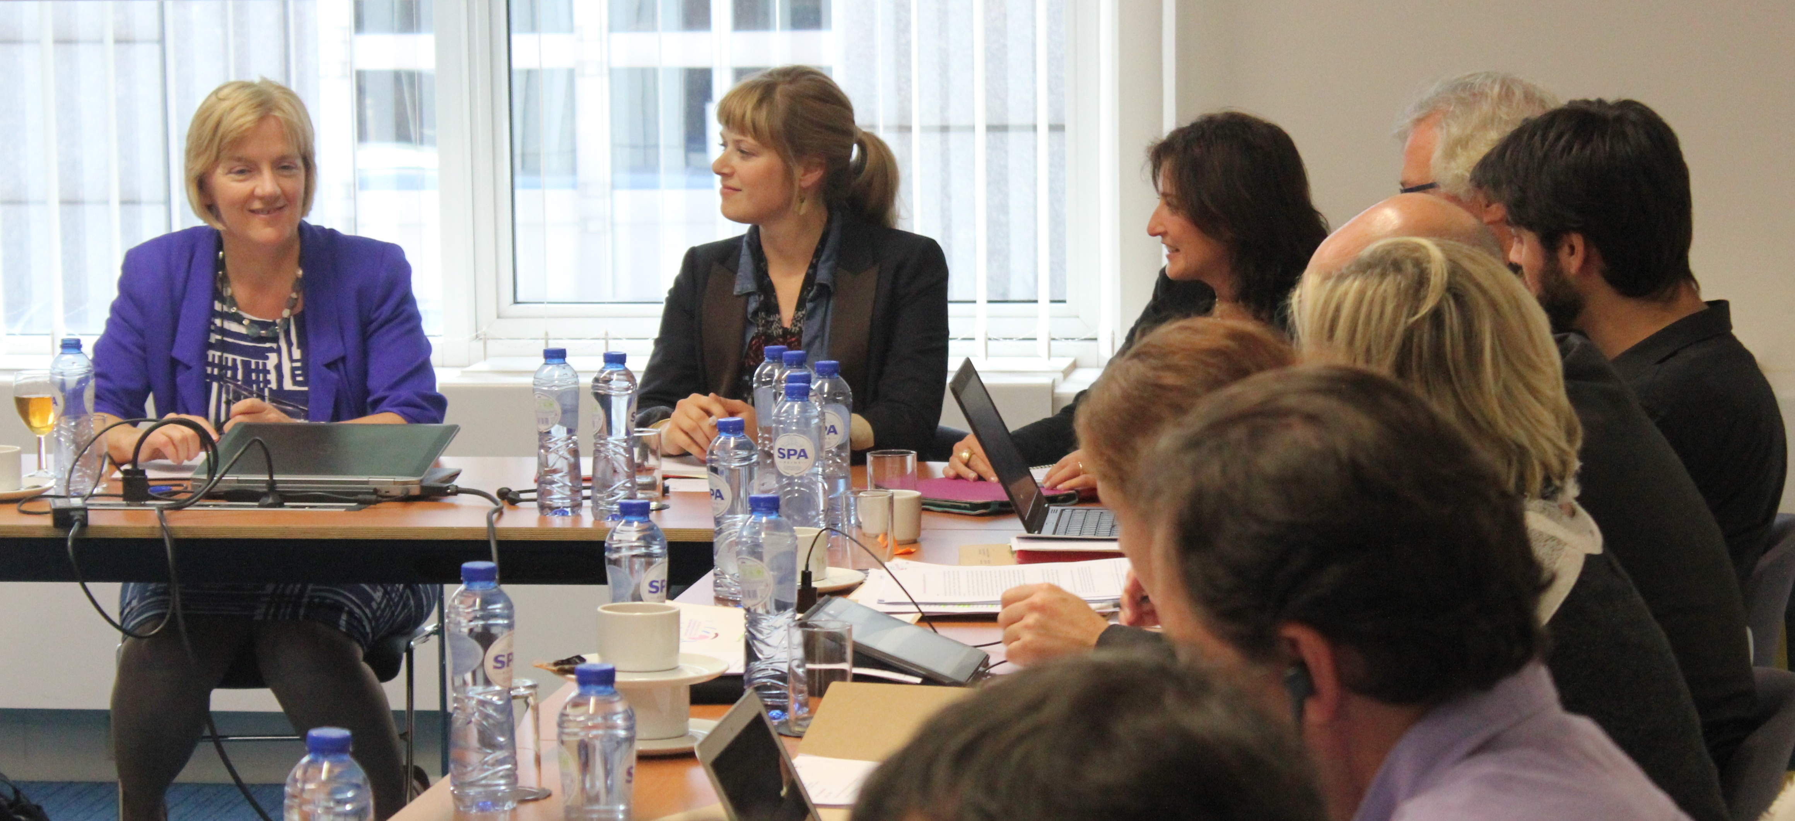

The Committee priorities are: post 2015, financing for development, tax justice, climate change, growing inequality and gender. The new EU Commissioner on Development committed to 0.7% of EU budget to be spent on development aid and mentioned the Financial Transactions Tax.
Participants raised the need
- to include social dialogue in EU development policies.
- for the EU development strategy to be long term, such as the African Union vision 2063
- recognition and participation of trade union as actors in development and as distinct from NGOs
Linda Mc Avan answered that in the European parliament, trade unions are seen as more political than NGOs, hence the nervousness around their participation in development debates, and there is little knowledge of the work of trade unions in the South and the trade union north-south cooperation.
TUDCN PLAN OF ACTION (CONTINUED)
- Regional action plans 2014-2015: state of play

  - Africa: adjustment of work plan 2014-2015
The work plan for Africa has been reviewed. There is some research though in certain countries on post 2015. Work should be done to influence the EU-Africa strategy.
  - Latin America: Partnership meeting Central America and work plan 2014-2015
The strategy of the Development Platform for the Americas (PLADA) has already been presented to the governments of Chile, Uruguay and Costa Rica. An agreement has been signed between PLADA and the Economic Commission for Latin America (ECLA).

The regional network also co-organised a seminar in Costa Rica to evaluate trade union partnerships in Central America and the Caribbean based on the Trade Union Development Effectiveness Principles. The initiative will probably be replicated in South America.

  - Asia: Regional workshop December
In November, there will be the annual event of ITUC Asia Pacific with Solidarity Support Organisations to exchange information on activities and discuss how to improve coordination.
- Other matters of concern

- European Policy Forum for Development
Matt will participate in a panel with the EU Commissioner for Development in the panel on post 2015 (the EU will adopt a common position by the end of the year)
The TU have official representation to the PFD at global, European, and regional level. The representation at European level has to be revisited. So far the ETUC and CSC/BE have been covering the 2 seats at disposal. However the ETUC is willing to leave its seat at disposal to TUDCN European organisations willing to engage. The secretariat will send a notice shortly to the EU WG to call for a show of interest.
- European Year for Development: exchange of views
Trade unions will use this year as an opportunity
- to showcase to the European Union how trade unions are development actors, with case studies of trade unions solidarity projects.
- to illustrate the work trade unions are doing on development education
- to scrutinise the EU policies on social protection and decent work.
The secretariat will evaluate how to best organise in practice these suggestions and will give feedbacks to network’s members.

