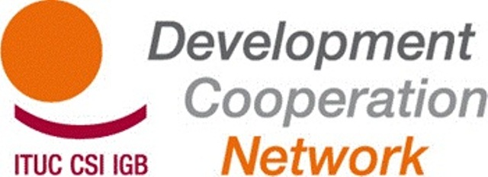

Report of the TUDCN General Meeting
17, 18 & 19 April 2013
Metalskolen, Slangerup, Denmark

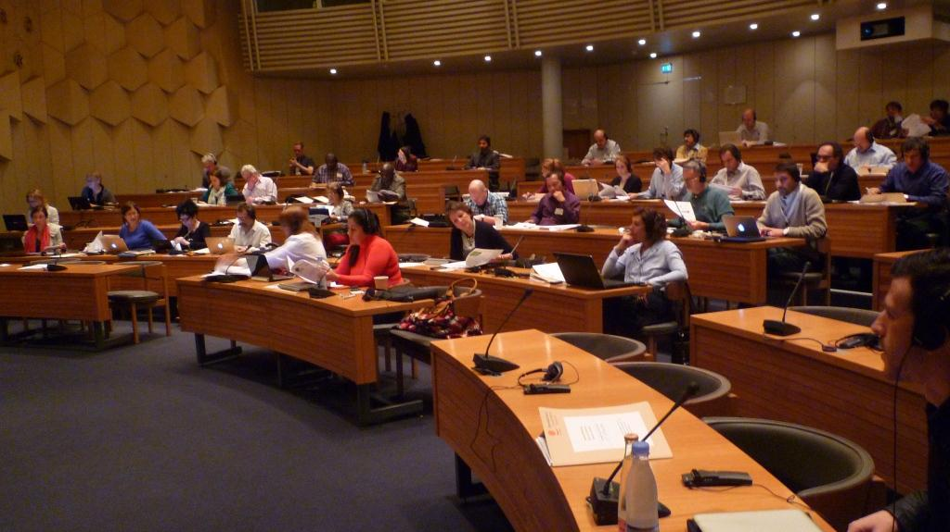

Wednesday 17 April 2013

- Opening of the meeting – welcome of the participants and presentation of the agenda
Wellington Chibebe (ITUC DGS) chaired the session and opened the General Meeting. Jan Dereymaeker (ITUC/TUDCN) welcomed the participants and thanked the Danish Metalscholen for its welcome. Paola Simonetti (ITUC/TUDCN) then presented the agenda. Each participant briefly introduced themselves (please see the participants list in annex).
A video message from Sharan Burrow, General Secretary of the ITUC was shown to the participants.
- Approval of the report from the previous TUDCN meeting
The report of the last General Meeting in Paris was adopted.
- Presentation of the TUDCN Activities Report: November 2012 – April 2013
Matt Simonds (ITUC/TUAC) presented an overview of the latest developments relating to the post-2015 development agenda particularly from the meetings in Monrovia (Liberia) and Bali (Indonesia). Matt reminded all present that the High Level Panel consists of 27 Experts that will deliver a report to the United Nations Secretary-General containing their recommendations for the new development framework. The Secretary-General will then decide whether to keep their recommendations or to rework them before presenting them to the UN General Assembly in September.
Jan underlined the importance of collaboration with the Global Union Federations, particularly with EI-IE and PSI. Collaboration with the EI-IE was excellent in Monrovia and Bali.
- New TUDCN members
New participants took the floor to present the latest developments in their organisation, country or region. All these contributions are available online.

- Presentation and discussion of the external TUCDN Evaluation report 2011-2013
The evaluators (Dirk Van Esbroeck and Barbara Simaeys) presented their evaluation (see ppt) and shared their conclusions and recommendations: the Network should extend its operations further with members in the South, develop a global sustainability strategy, devote more attention to strengthening its internal capacities, develop an approach and strategy for global campaigns, should first consolidate and then increase its resources (extension of the Secretariat).
The evaluators answered members’ questions highlighting that there are two recurring problems in the Network:
- The participation of organisations from the South: increased participation from the South does not mean that it is necessary to invite more people from the South to the General Meetings; this means that a regional dynamic must be created and more importance must be given to the South’s expectations. Nevertheless, each continent is different, the Network must adapt to the dynamic of each continent.
- Interaction between the TUDCN and the ITUC: As the TUDCN is an open network and the ITUC is a formal organisation, they must agree on mutual principles of governance.
Maurice Bossuat (CFDT) congratulated the evaluators on their work particularly given the time allocated. Nevertheless, he stated that this was not the opportune moment to discuss the recommendations because it is up to the Network to decide how to proceed.

Thursday 18 April 2013

- TUDCN Public Report 2011-2012
The second day opened with a presentation by Marion Levillain (TUDCN/ITUC) of the key points of the TUDCN Public Report 2011-2012.
This report presents the TUDCN’s major achievements over the last two years and also gives a detailed account of the advocacy carried out by the Network.
Santiago Gonzalez Vallejo (USO) stated that what did not work should also be included in the report.
Maresa Le Roux (ACLVB) stated that South-South Cooperation should be included in the report (Seminar organised in Florianopolis in August 2012).
According to Sergio Bassoli (CGIL), the ITUC and the trade unions do more than the network in terms of international cooperation. We must therefore find a way to link the report with the activities of other ITUC departments.
Stijn (ACV-CSC) considered that future prospects as well the recommendations and objectives for the upcoming months should be included.
In terms of the format, a list of the Network members should be included with their website address in order to have access to more information about what is happening on the ground.
Rekson Silaban (KSBSI) stated that he would like to see more information in the report on the uses of the trade union principles and guidelines in terms of development effectiveness. The Secretariat should include examples sent by the affiliates.
Frédérique Lellouche (CFDT) stated that Chapter III (dedicated to the Network’s communication and awareness-generating tools) should be developed further. The Secretariat’s research should be valued, particularly the significant work carried out in terms of advocacy.

- TUDCN Advocacy Strategy 2013-2014 – Evaluating the challenges of a new development model
This document looks at the different institutional frameworks and the associated methodologies.
(See later discussions: point 13)

- TUDCN Mission and governance
Paola briefly presented the major proposals from the document:
- General Meetings: An increase in the size of the regional representations (5 per region including MENA and PERC). The regional organisations will have to nominate the participants and their substitutes,
- FSG: must be more involved in the planning and the implementation of the Network’s activities. A proposal has been made to increase the number of members per region (2 affiliates and 1 regional representative per region) with an unlimited mandate; participation by the MENA and PERC regions to be reviewed,
- Working groups: the “sign-off” procedure will be used going forward (if no one objects, the document will be adopted). Ad-hoc meetings will continue and will be open to all interested members,
- Secretariat: the newsletter will be distributed by the regional organisations, the website will be improved (a calendar will be added), new brochures…
Nevertheless, no change was made to the TUDCN Mandate and objectives
- Presentation of the Trade Unions in Development “Manifesto’
Nicolò Giangrande, an intern at the Secretariat presented the Manifesto on trade unions in development. The Manifesto should serve as an identity card for the TUCDN.
Our major challenge is to fight inequalities without which development cannot be sustainable. Within this context, the role of the trade unions is more important than ever. The trade union voice must be heard. Our strength as a trade union in cooperation is based on the 8 trade union principles on development effectiveness.
Social dialogue is the fundamental tool for decent work. Furthermore, we need a human-rights based approach. South-South cooperation is also an important point to strengthen our links with countries in the South.
Rekson would like the Manifesto to make further references to the ILO standards, only the human-rights standards have been included.
The participants then broke up into three working groups to discuss the proposals in relation to TUDCN governance and the Manifesto on trade unions in development.

- Round-table discussion on the post 2015 institutional process and framework’s contents:
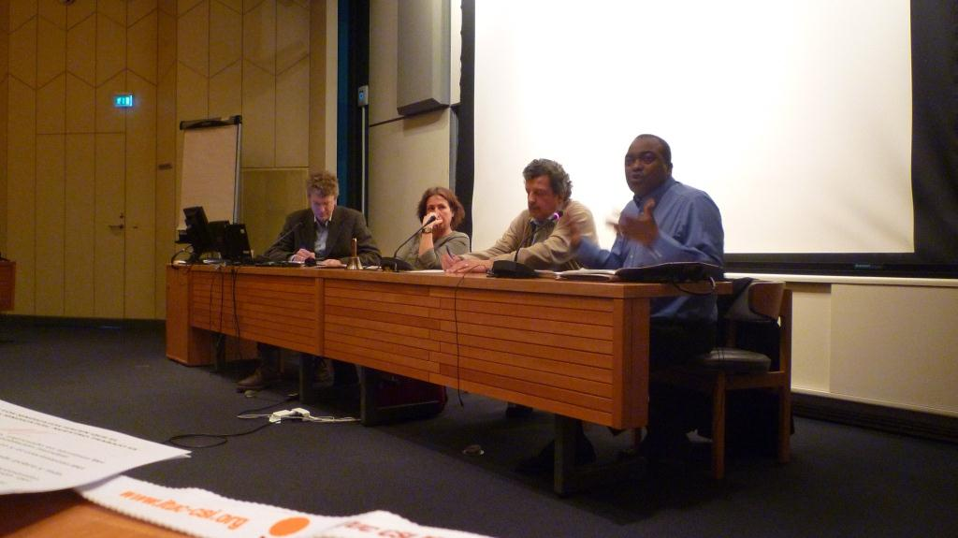

After lunch, Claire Courteille, ITUC Equality Department Director moderated a round-table discussion with Lars Engberg-Pedersen from the Danish Institute for International Studies- DIIS and member of the UN Advisory Group thematic consultation on inequalities, Roberto Bissio, Director of the Instituto del Tercer Mundo (Social Watch Coordinator) and Claude Akpokavie, ACTRAV, ILO
Claire opened the debate by outlining the ITUC’s priorities for the post-2015 framework. She established two priorities for the new post-2015 development framework: decent work and social protection. In order to implement these priorities, resources are needed, political courage and also a taxation policy that is favourable to social protection: for this, we must fight tax evasion. The redistribution of power is an important theme. Rights are also crucial as this is what makes development sustainable.
Lars Engberg-Pedersen presented the strengths and weaknesses of the MDGs.
In his view, gender equality will most certainly be included in the new post-2015 development framework, as well as social protection floors and methods to measure progress in the poorest countries; on the other hand, he believes that the presence of a goal on the reduction of inequalities is very unlikely.
According to him, one of the possibilities for measuring inequalities between countries is the use of the Palma ratio. The ratio calculates the difference between the richest 10% and the poorest 40%. Consequently the higher the ratio, the greater the gap between rich and poor. Worldwide, the ratio is 32: the 10% that earn the most earn 32 times more than the 40% that earn the least.
Roberto Bissio then retraced the origins of the MDGs and the context of the new debate. The MDGs are a system where no accountability mechanism exists; it is also a mechanism that has no “teeth”, in other words, nothing happens if the goals are not met, it is at the end of the day a system where the States risk being punished if they meet their goals (for example, the loss of trade privileges reserved for less developed countries).
In his view, it would not necessarily be a catastrophe if no new development goals were adopted on account of overly disparate viewpoints. We already have commitments from the United Nations that “frame” development (human rights, ILO Conventions, women’s rights…). A new framework should necessarily position itself within this perspective that is universal and rights based: the post-2015 framework should be universally applicable with accountability mechanisms for both developing countries and developed countries with each being held accountable for its commitments.
It is essential that civil society is involved in the definition of the goals and their indicators.
MDG 1 states that that the proportion of people living in extreme poverty should be reduced by half before 2015. Therefore, for over a decade, the debates and the research carried out by UN development agencies, governmental cooperation agencies in donor countries, governments of poor countries and many NGOs have been concentrated on extreme poverty. Nevertheless, the key to the new agenda could be placed elsewhere: equality. This is what has emerged from several months of consultation by specialised UN agencies with academics and CSOs. There were already inequalities in 2000 but these have even worsened in some cases.
Claude Akpokavie then gave the ILO’s point of view on the current discussions on the post-2015 framework. The main question to ask yourself is what type of development model that we would like to implement. This question should be answered before any discussion on the post-2015 framework.
The fundamental goal is the reduction of poverty. The World Bank has acknowledged wanting to eradicate extreme poverty (less than $1.25 per day). However this goal lacks ambition. We cannot exclude decent work. The elements of the Decent Work Agenda (DWA) are fundamental in order to ensure in-depth reform of the model. Rights are essential; otherwise it is just promises and talk. Decent and productive jobs are the source and foundations of social and economic development and of the system of redistribution and this, with social security and social protection that ensures development for all. Developing the goals should be based on social dialogue which is the tool used by workers to participate in development decisions which affect them first and foremost.
September will be a key month. The overall process should:
- Target the number 1 problem: poverty and exclusion. Extreme poverty must be eradicated : no one should live below the poverty threshold
- Guarantee the protection of basic human rights, with a solid legal framework
- Promote an inclusive and sustainable development framework
- Incorporate a global reference framework that includes all countries but which also reflects the different levels of development
- Include a goal on governance, on human rights and the key ILO Conventions

Nathalie Guay (CSN) stated that certain concepts should be examined such as the limited references to governance. She also asked Claire why a differentiation has been made between decent work and social protection. Is social protection not part of decent work? Claire answered that the majority of people do not really understand what decent work is. It is in order to show that decent work is not just the decent working hours or a decent salary that the ITUC differentiated decent work from social protection: the aim is to highlight social protection.

Bandula Kothalawala (TUC) stated that he did not see the advantage of the Palma ratio over the GINI system. Lars Engberg-Pedersen responded that in his opinion the GINI coefficient is very difficult to read but that the Palma ratio is clearer and easier to use, it is more interesting to analyse the 10% above and the 40% below rather than focusing on the 50% in the middle.

Jan stated that in his opinion the model to follow is that of the ILO, a regulated system reflected in national legislation, with its tripartite approach and regulatory mechanism.

- Working groups
French-speaking working group: main points from the Group:
• The goals should be universal and applicable to all countries
• Power should be redistributed between different actors
• The need to work towards good governance including the rule of law and the respect for human rights
• It is not only about setting goals, the commitments must also be taking into account; a rights-based approach and international human-rights tools must be valued.

Spanish-speaking working group: taxation, corruption and tax havens were omitted from the pillars of decent work.
The system that protects human rights and the ILO system of Conventions constitute the focus of attention for the trade union movement. We should focus on this system. The ILO is the United Nations agency dedicated to the regulation of labour relations. The trade union movement must reject any attempt to deflect the ILO’s mission towards other bodies such as the UNDP.
English-speaking working group: The Group considered that the goals should be global and universal but that they should be translated into national goals, in accordance with national specificities.

- Trade union contribution to the European Commission Communication
After the working groups, the participants took part in a plenary session to discuss the trade union contribution to the European Commission Communication entitled “A decent life for all: Ending poverty and giving the world a sustainable future”. This contribution was developed in the Working Group on the EU. On the whole, the communication is satisfactory because it contains elements on decent work and social protection as outlined by the trade union movement. One unsatisfactory point in the Communication concerns political coherence which is an essential element of the success of any effective development strategy.

Friday 19 April 2013

Jan presented the conclusions of the three working groups on TUDCN governance and the Manifesto (see points 8 and 9)
- General Meetings:
- the current meeting frequency of 2 meetings per year should be maintained,
- there are too many documents to read,
- relations with the ILO should be strengthened
- more discussions should be regionalised,
- there should be a balance between advocacy and trade union cooperation,
- a list of Network members should be available on the website and also a list of representative names.

- FSG/WG: the role of the FSG is not very clear; holding the FSG meetings “back to back” with the General Meetings is not useful because there can be an overlap in the discussions. Furthermore, its working methods and terms of engagement need to be clarified.

- With regard to the Manifesto, despite the shortage of time to discuss this subject, a number of additions were proposed by the participants :
- Need for a new development model
- Importance of the ILO regulations and standards
- Reference to tax havens
- More reference to South-South Cooperation
- Decentralisation
There is a need to focus more on our demands instead of dedicating the introduction to the economic situation, a situation that we are all already familiar with.

- Guidelines (proposals from the Secretariat) :
- General Meetings: the discussions regarding processes should be limited and more time should be allocated to discussing the actual content
- FSG: further discussions are needed and this item will be revisited at the next meeting
- Manifesto : an online debate will be launched, the new version will be redrafted before mid-July and will be presented at the next General Meeting

- Planning of the new project phase : strategies for the next programme

- +2015: a trade union Working Group will be set up. This group will supervise the campaign for the new post-2015 development framework.

- GPEDC: a “shadow” working group will be set up. Interested members should apply.

- South-South Cooperation: it is not easy to ascertain where the current debates are taking place; it is being widely discussed in the BRICS. We need to see if Kjeld (TUCA) could get involved in a working group on this subject. It would be up to the TUCA to lead a working group but this group would be a global group. In response to Rekson and Stijn who enquired about the possibility of having a Chinese representative in this group, Wellington stated that China is an important issue but it is above all a political problem. Nevertheless they represent a force that we need to take into account, particularly in Africa. Adrien agreed with Wellington that China cannot be ignored because it has become a development partner in Africa, which is why the ITUC needs to get in contact with China.

- CPDE: the trade unions represent approximately 10% of the total members. The last meeting of the platform took place in Nairobi in December. A delegation attended but unfortunately this delegation did not include represents from America or Asia.
- Three working groups were set up within the platform :

- An environment conducive to civil society
- Accountability and transparency
- Promotion of the human-rights based approach: the ITUC proposed leading this group, all organisations who would like to participate are welcome.

- OECD-DAC: we propose to organise an annual forum with the OECD-DAC/TUDCN/CSC in order to discuss issues of mutual importance and to strengthen potential cooperation on issues of shared-interest.

- UNDCF: provides a genuine forum for trade union participation but it does not develop policies. The last meeting took place on the 6 and 7 June in Addis-Ababa. We need to assess the future of the UNDCF in relation to the new UN post-2015 development framework.

- EU Development policies:
- Political development forum: Trade unions have a total of 9 seats.

- Democracy and human rights: the TUDCN has been following this area for some time now.

Myriam Luz Triana (CGT Colombia) stated that in her opinion it is serious to state that the Human and Trade Union Rights department does not have the capacity to act. Visibly moved, she told the participants that a Colombian trade unionist had just been murdered. We need to act now to stop any similar acts!
She would also like to see collaboration between the TUDCN and the Human and Trade Union Rights department.
The Secretariat will shortly send a form to the organisations so that they can select the Working Groups in which they would like to participate.
Jan thanked Metalscholen for their warm welcome and also the interpreters for their excellent work.
Annex: Participants List
United Kingdom | TUC | Bandula | Kothalawala | bkothalawala@tuc.org.uk
Italy | UIL | Massimo | Di Pietro | m.dipietro@uil.it
France | CGT France | Marie-Christine | Naillod | mc.naillod@cgt.fr
Romania | NTUC Cartel ALFA | Catalin | Toscuta | international@cartel-alfa.ro
Spain | USO SOTERMUN | Santiago | Gonzalez Vallejo | areainternacional@uso.es
Belgium | Education International | Delphine | Sanglan | delphine.sanglan@ei-ie.org
Belgium | Education International | Nicholás | Richards | nicolas.richards@ei-ie.org
Turkey | DISK | Eliaçik | Kivanç | kivanceliacik@disk.org.tr
Netherlands | CNV Internationaal | Marie José | Alting von Geusau | k.zwart@cnv.nl
Belgium | World Solidarity Belgium | Bart | Verstraeten | bart.verstraeten@wsm.be
Hungary | MSZOSZ | Károly | György | kgyorgy@mszosz.hu
Italy | CGIL | Sergio | Bassoli | s.bassoli@cgil.it
Netherlands | FNV Mondiaal | Dian | Van Unen | dian.vanunen@vc.fnv.nl
Belgium | ACLVB | Maresa | Le Roux | maresa.le.roux@aclvb.be
France | CFDT | Maurice | Bossuat | mbossuat@cfdt.fr
France | CFDT | Frédérique | Lellouche | flellouche@cfdt.fr
Belgium | ACV-CSC | Stijn | Sintubin | stijn.sintubin@acv-csc.be
Spain | ISCOD | Javier | Vaquero Andaluz | jvaquero@iscod.org
Italy | ISCOS | Gemma | Arpaia | arpaia@iscos-cisl.org
Spain | CS CCOO | Felix | Ovejero Torres | fovejero@ccoo.es
France | Force Ouvrière | Marjorie | Alexandre | malexandre@force-ouvriere.fr
Denmark | LO-FTF | Henrik | Als | als@loftf.dk
Cyprus | DEOK | Mary | Vasilakka | vassilakka@cytanet.com.cy
Belgium | FGTB | Thierry | Aerts | thierry.aerts@fgtb.be
Belgium | European Commission | Virginia | Manzitti | Virginia.MANZITTI@ec.europa.eu
Canada | CSN | Nathalie | Guay | nathalie.guay@csn.qc.ca
Brazil | CUT | Antonio | Lisboa Amâncio do Vale | lisboa@cut.org.br
Argentina | CGT Argentina | Marita | González | maritagonzalez@cgtrainternacional.com.ar
Brazil | TUCA | Martha | Ayala | martha.ayala@csa-csi.org
Colombia | CGT Colombia | Myriam | Alvis Triana | miryamluztrianaalvis@gmail.com
Togo | CSI-Africa | Yaovi Beleki | Akouete | adrien.akouete@ituc-africa.org
Rwanda | COTRAF | Dominique | Bicamumpaka | cotraf@cotraf.org
Ghana | TUC | Kwabena Nyarko | Otoo | otooshark@yahoo.com
Singapore | ITUC-AP | Haridasan | Parayarikkal | haridasan@ituc-ap.org
Indonesia | KSBSI | Rekson | Silaban | reksonsilaban@hotmail.com
Jordan | ITUC Jordan | Nezam | Qahoush | ituc-jor@orange.jo
Palestine | PGFTU | Atef | Saed | atefsaed@hotmail.com
Philippines | FFW | Jose | Cayobit | jdcayobit@yahoo.com
ITUC
Belgium | ITUC | Wellington | Chibebe | wellington.chibebe@ituc-csi.org
Belgium | ITUC | Jan | Dereymaeker | jan.dereymaeker@ituc-csi.org
Belgium | ITUC | Paola | Simonetti | paola.simonetti@ituc-csi.org
France | ITUC/ TUAC | Matt | Simonds | simonds@tuac.org
Belgium | ITUC | Marion | Levillain | marion.levillain@ituc-csi.org
Belgium | ITUC - Intern | Nicolo | Giangrande | nicolo.giangrande-intern@ituc-csi.org
Belgium | ITUC | Claire | Courteille | Claire.Courteille@ituc-csi.org
Belgium | ITUC | Alison | Tate | alison.tate@ituc-csi.org
Speakers
Uruguay | Social Watch | Roberto | Bissio | rbissio@item.org.uy
Switzerland | ILO | Claude | Akpokavie | akpokavie@ilo.org
Denmark | DIIS | Lars | Engberg-Pedersen | lep@diis.dk
External Consultants
Belgium | South Research | Dirk | Van Esbroeck | dirk.vanesbroeck@southresearch.be
Belgium | South Research | Barbara | Simaeys | barbara.simaeys@southresearch.be

