TUDCN General Meeting
18-19-20 March 2014
São Paulo, Brazil
Logistical information
Currency
The currency of Brazil is the real. Its rate is quite fluctuating, as of the 6th of March: 1 Rl ≈ 0.31 € or 1 € = 3.18 Rls.
Vaccination
Brazil doesn’t require any vaccination.
However, please check if you your vaccinations against tetanus, polio, diphtheria and pertussis and hepatitis A are up-to-date.
The yellow fever and malaria vaccination isn’t recommended for travels to the following coastal cities: Rio de Janeiro, São Paulo, Salvador, Recife, and Fortaleza. But it will be recommended if you travel outside these cities.
Kindly note that the entrance in Brazil is now subject to the obligation of vaccination against yellow fever for travellers from the following regions or countries: French Guiana, Bolivia, Colombia, Ecuador, Peru and Venezuela. The original certificate of vaccination is required.
Electric plugs
From one region to another, the electrical outlets are powered either 110 V or 220 V, with two or three-pin plugs. The ideal is to buy an adapter, preferably before you leave, because you do not find it so easily on site.
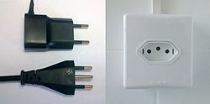
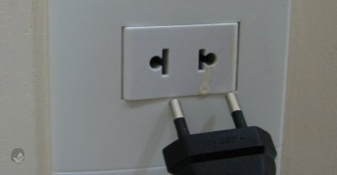
Climate
The month of March corresponds to the end of the summer in Brazil. The average low temperature in São Paulo is about 18 °C and the average high temperature is near 26-27 °C.

Programme
The meeting will be focused on the development model we want, taking stock of some of the major strategic challenges for the trade union movement in the development arena. We will also be dealing with the reporting on the advocacy and partnership activities of the TUDCN and the planning of its future strategies and activities.
Accommodation
You will be staying at the Marabá Palace Hotel
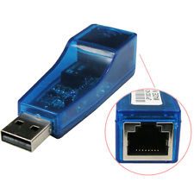
Av. Ipiranga, 757, São Paulo, CEP 01039-000
http://www.hotelmaraba.com.br/
We have made a hotel reservation for you according to your itinerary. Should you have any questions, please contact marion.levillain@ituc-csi.org
Please note that the internet connection in the rooms is by CABLE. As some notebooks do not have connection by cable, you will need a RJ45 to USB Cable.

We will arrange taxi-mini bus collection at the airport and to the airport after the meeting. It will be grouped taxis, that’s why in some cases, you will have to wait for a short period for the next flight to arrive. I’ll send a specific email on this issue.
If you prefer to make your own arrangements, please let me know.

Venues of the meeting
The meeting will take at the TUCA headquarters, at 10 minutes walk from the hotel:
Rua Formosa, 367 – 4º andar – Cj 450 – Centro – CEP 01049-000
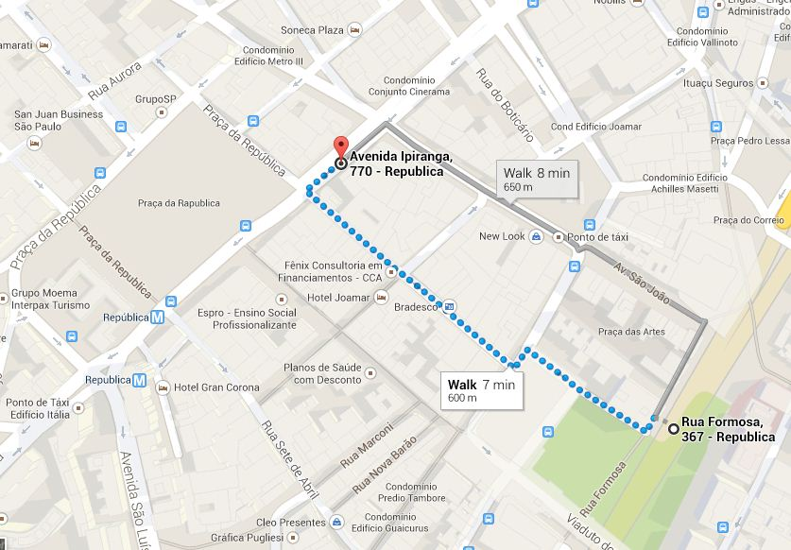
Meals provided

All the lunches during the meeting will be provided.
You will receive allowances for the lunches and dinners that will be at your charge, before and after the meeting according to your itinerary.
The dinner of the 16th and 17th will be provided at the hotel.
If you have other plans, please let us know so that we can notify the hotel.

The dinner of the 18th will be kindly offered by the CUT and UGT Brazil.
The dinner of the 19th will be free. You will be given an allowance on the spot and a list of suggested places to go.
Travel reimbursement
In order to get your travel costs reimbursed, (if you were informed that you were entitled to do so), kindly fill in the reimbursement form that will be sent after the meeting and return it along with the ORIGINAL boarding passes to Marion Levillain – DGS-DCE – ITUC International Trade Union Confederation - Boulevard du Roi Albert II 5, B 1, BE-1210 Brussels, Belgium.
Languages
Interpretation will be provided in English, French, Spanish and Portuguese.

