Trade Union Development Cooperation Network
Seminar on "Partnerships for Development"
San José, 28-29 August 2014
NARRATIVE REPORT
Contents
1. Objectives of the seminar 2
2. Participants 2
3. Agenda 2
4. Contents 3
Thursday 28/08: "Trade Union Cooperation in Central America and the Caribbean: DIAGNOSIS" 3
Friday 29/08: “Trade Union cooperation in Central America and the Caribbean: improvement mechanisms for more effective cooperation" 6
Follow-up 8
ANNEX 1: TUDCN Projects Directory 9
ANNEX 2: TUDEP and support materials 10
ANNEX 3: LIST OF PARTICIPANTS 11
ANNEX 4: AGENDA 12

FINAL REPORT

Objectives of the seminar
  - To provide access to a specific map of the trade union cooperation initiatives in the Central American and Caribbean subregion.
  - To assess trade union cooperation in Central America and the Caribbean based on trade union development effectiveness principles and the tool for their implementation (TUDEP).
  - To develop and implement mechanisms to generate more effective cooperation in the Central American and Caribbean subregion.

Participants
The seminar was attended by 24 members (9 women - 39%) of the ITUC/TUCA Trade Union Development Cooperation Network (TUDCN), including:
- 10 cooperating organisations, representing 8 countries (CGIL and ISCOS-CISL Italy; USO-SOTERMUN Spain; FGTB and FOS Belgium; 3F Denmark; FES Germany; CUT Brazil; Alternatives CSN Canada; SASK Finland);
- 9 TUCA affiliates representing 8 countries (CATS El Salvador; CGTG Guatemala; CTH Haiti; CUTH Honduras; UNT Mexico; CST Nicaragua; Convergencia Sindical Panama; CTRN and CMTC Costa Rica);
- 1 Global Union Federation (IUF);
- 4 members of the ITUC/TUCA TUDCN Team.
See the Participant List in Annex 3.

Agenda
See Annex 4.

Contents

Thursday 28/08: "Trade Union Cooperation in Central America and the Caribbean: DIAGNOSIS"

Session I: Opening, TUDCN introduction and presentation of seminar objectives; introduction of participants
Welcome: The opening was attended by Marvin Rodríguez, titular member of the ITUC General Council and general secretary of the Confederación de Trabajadores Rerum Novarum (CTRN) from Costa Rica.
Marvin Rodríguez underlined the importance of this activity aimed at strengthening the solidarity ties between trade union organisations that are partners in cooperation. He also passed on the regards of Amanda Villatoro, the TUCA trade union policy and education secretary, who was unable to attend the event due to a last minute change in her schedule.
Presentation of ITUC/TUCA TUDCN: Paola Simonetti (ITUC-TUDCN team) and Giulia Massobrio (TUCA-TUDCN team) gave a brief presentation of the Trade Union Development Cooperation Network (TUDCN) and its work. After showing the NETWORK'S VIDEO, Paola Simonetti talked about the Network's structure and its main activities.
The Network was born in 2008, following the Founding Congress of the ITUC in 2006, which identified development cooperation as one of the organisation's policy priorities, with a view to giving fresh impetus to advocacy, capacity building and trade union cooperation.
Based on these objectives, the TUDCN's mission (http://www.ituc-csi.org/development-cooperation) is centred on two interrelated areas:
1) Supporting trade unions and giving them a voice in development policy debates at various levels (global, regional and national), placing decent work at the core of all development agendas.
2) Improving development cooperation effectiveness among trade union actors, strengthening the coordination mechanisms and methodologies used in the context of cooperation programmes (international solidarity). This includes:
- Improving the impact and quality of trade union cooperation
- Supporting synergies and coordination
- Strengthening the recognition of trade unions as development actors in their own right
- Increasing the support for projects

The Network is an open and inclusive structure, based on the voluntary commitment of the organisations involved, bringing together various affiliated trade union organisations, solidarity support organisations (SSOs), the regional organisations of the ITUC, Global Union Federations (GUFs), the European Trade Union Confederation (ETUC) and the Trade Union Advisory Committee (TUAC) to the OECD.
Strengthening regional networks for development cooperation is clearly central to the overall Network's objectives in terms of fostering and coordinating international solidarity actions.
Giulia Massobrio presented an overview of the work the TUCA-TUDCN is doing in the Americas, in line with both Resolution 11, approved by the TUCA Congress in 2012, and the Development Platform for the Americas - PLADA (TUCA, 2014). She made specific reference to the capacity building initiatives the Network has been developing together with ECLAC (on the post-2015 agenda), the advocacy work at international level (High Level Meeting in Mexico in 2014 and the EU Policy Forum on Development, for example), and the efforts to raise the profile of the TUCA Network's initiatives (new webpage, contribution to "Reality of Aid" 2014 Report and the ILO report on South-South and Triangular Cooperation).

Introduction to the activity and presentation of the methodology: Diego López González (ITUC-TUDCN team) explained the objectives of the activity and presented the agenda of the two-day seminar, stressing the importance of the group's assessment of the materials to be presented, with a view to ensuring their continual improvement.

Introduction of the participants and their expectations: the participants were invited to introduce themselves (name, organisation, countries, role/position) and to share their expectations with regard to the activity.

The expectations can be resumed as following:

  - to learn more about the Network and to take part in it;
  - to learn about the projects underway in the Central American and Caribbean subregion;
  - to learn about the TUDEP assessment tool, with a view to better coordinating trade union cooperation efforts and making them more coherent and effective;
  - to assess the nature and scope of the impact, in concrete terms, of trade union cooperation on the subregion.

Session II: Mapping trade union cooperation in the subregion - Presentation of the information gathered on trade union projects in the Central American and Caribbean subregion and discussion of the conclusions
Presentation of the Trade Union Development Projects Directory: Diego López presented the trade union development projects DIRECTORY set up by the TUDCN. The Directory is an interactive online tool providing an overview and description, by country or by theme, of the trade union projects being developed, and their characteristics (partners, objectives, activities, etc.).
This tool was created on the request of the Network members, as a way of sharing information and fostering coherence between trade union development cooperation projects. Diego López also pointed out that the Directory can only be useful to the organisations if they are committed to sending regular information on their cooperation activities, so that the database can be kept up to date.
Mapping trade union cooperation in the subregion: a questionnaire was sent to all the trade union organisations taking part in the Network, all the GUFs and all the TUCA affiliates in Latin America and the Caribbean, with a view to mapping the trade union cooperation work in the subregion.
The data on the Official Development Assistance (ODA) contributions made to the subregion in recent years was presented as a frame of reference for the discussion. This revealed the general trend of an increase in ODA to Central America and the Caribbean until 2010, followed by a sharp fall in 2011 and 2012 as a result of the cuts related to the economic and financial crisis. It also highlighted the fact that one of the main traditional donors - Spain - has considerably reduced its ODA, but still provides a high level of funds.
Based on the forms received from the majority of the participants, the information was systematised and presented to the group as input for the discussion. The countries standing out in terms of the number of projects were El Salvador, Honduras, Nicaragua and Guatemala. In terms of themes, it emerged that many of the trade union projects registered were related to trade union rights, social protection, trade union organising and gender equality.
The discussions on the mapping led to the following suggestions:
- explore the possibility of the Directory not only listing projects but political processes and agreements, as well as the different forms of trade union cooperation;
- revise the list of themes and add a brief description of each one;
- include a filter to select projects by branch of activity;
- include information on ILO projects.

Session III and IV: Presentation of the trade union development effectiveness principles: process, principles and relevance in trade union cooperation work
Trade union development effectiveness principles: Diego López (ITUC) presented the "Trade Union Principles and Guidelines on Development Effectiveness" collectively drawn up by the TUDCN and approved by the ITUC General Council.
Following the presentation of the principles and guidelines set out in the document, the group made the following observations:
- underline the importance of solidarity, as the foundation of universal social justice, and add ethics and honesty;
- regarding the partnership principle, provide a better explanation of the reference to the solidarity relationship between colleagues (equals);
- mention other groups such as the elderly, indigenous peoples and LGBT within the principle of inclusiveness and equality;
- the terms "supporting partners" and "receiving partners" imply differentiated roles and place the emphasis on the financial aspect of the cooperation relationship;
- the title could mention the concept of international solidarity;
- underline the positive aspect of the reference to local capacity development and exit strategies;
- reflect on the need to establish mechanisms to ensure compliance with the principles.
Trade union development effectiveness profile: having concluded the discussion on the principles, the TUDEP TOOL (trade union development effectiveness profile tool) was presented. The TUDEP is a learning tool designed to help trade unions assess how to improve their development cooperation programmes. The main objective of the TUDEP tool is to contribute to improving the quality and effectiveness of trade union development cooperation work by helping partners to reflect on their practices as well as the principles and values that underpin their work. It also helps to facilitate the monitoring and assessment of the progress in the use of the principles and guidelines for trade union development effectiveness. This tool was developed by the trade union organisations within the TUDCN and approved by the Network.
The participants first worked individually, completing the questionnaire based on their own cooperation experiences, in order to familiarise them with the tool.

Friday 29/08: “Trade Union cooperation in Central America and the Caribbean: improvement mechanisms for a more effective cooperation"

Session I: Group work was organised to examine and assess trade union cooperation in Central America and the Caribbean based on the trade union development effectiveness principles and the TUDEP tool; conclusions presented in plenary
The second day of sessions began with work in two groups, one comprising supporting partners and the other comprising receiving partners. Each group, based on the individual work done on the TUDEP questionnaire, answered the questions as a group and then presented the discussions.
Group work outcomes: the conclusion of the receiving partners work group was that the transparency principle is the weakest in trade union partnerships, followed by democratic ownership and autonomy. As regards the democratic ownership principle, the group underlined that in spite of the respect for the partner’s proposal, there are technical limitations on the part of the supporting partner (e.g. the limitations in terms of countries and themes for which public funds are allocated). The principle that scored the highest, and was considered to be the aspect of trade union partnerships that works the best, was coherence, followed by accountability.
The supporting partners work group, for its part, highlighted the inclusiveness and equality principle as being the most problematic, followed by accountability. The partnership principle scored the highest, being considered the least problematic, followed by the principles of autonomy and coherence, which were given the same scores.
As regards the problems in terms of accountability, the group underlined that they are linked to technical issues, given the complexity of the accountability procedures to be respected by the partners, who often lack technical preparation in project management. It considered policy to be the main source of the problems in terms of inclusiveness and equality, and highlighted the need to work on these issues more. It also commented on the sustainability issue and the risk factors in projects.
Suggestions regarding the TUDEP: the majority of the participants considered the tool to be a valid way of fostering constructive dialogue between trade union cooperation partners. The suggestions on how to improve on it are resumed as follows:
- More trade union language needs to be used and care must be taken in the translation of the original English text;
- Make the questions more concrete and direct;
- Include a glossary in the tool to explain certain concepts;
- Be careful with "two-way" (ambiguous) questions (internal and external assessment);
- Take into account the risk of not adding "obligations" in addition to those already imposed by the government donors;
- Greater emphasis needs to be placed on certain criteria specific to trade union cooperation, to reflect and clearly identify the specific characteristics of this type of cooperation;
- Broaden the application of the TUDEP tool to other types of trade union cooperation and processes (not only projects).

Session II: Group work to develop mechanisms to improve trade union cooperation in the Central American and Caribbean subregion
Following this exercise, the conclusions of each group were compared, leading to the observation that the gap was greatest in their perceptions of transparency, followed by accountability and inclusiveness and equality. A difference was also highlighted with regard to the coherence principle.
During the afternoon session, the differences observed and the aspects of these four principles that could be improved were discussed in two mixed groups. Group 1 worked on the principles of transparency and accountability and group 2 worked on the principles of coherence and inclusiveness and equality.
In its presentation of the conclusions, group 1 underlined that transparency does not only relate to financial matters but to policies. As regards transparency in terms of information, it concluded that better communication between the partners should be fostered. With reference to accountability, the group proposed that an ITUC-TUCA tool should be developed to set out criteria in terms of planning, monitoring and assessment, to serve as an outline/blueprint for projects.
Group 2 commented that the principle of coherence was not discussed as the participants largely agreed on this matter. This group's discussion focused on the principle of inclusiveness and equality. It underlined that there were different perceptions and therefore more areas of disagreement. The group pointed out that their organisations are committed to this issue and that tools and methods are needed to put policies into practice, as it is more difficult to secure results in this area.

Session III: Assessment of the work done, systematisation, conclusions and closing
Following this exercise, an assessment round was held to evaluate the seminar. The participants expressed their satisfaction with the event as an interesting and useful exercise and a good way for the Network to make concrete progress with its advocacy work. The following specific points were made:
- Satisfaction at having learned more about the work of the ITUC-TUCA TUDCN;
- Importance of interaction between the people working in the field of trade union cooperation, to ensure direct channels of communication, with a view to achieving better coordination and greater coherence;
- Utility of the TUDEP as a process tool fostering fairer and more effective trade union cooperation, and showing that the vision of the different cooperation partners is not so different;
- Importance of bringing together the political and technical sphere in any assessment of trade union cooperation, to ensure constant feedback between the two;
- Ensure the drawing up of many practical conclusions, to improve trade union cooperation;
- Continuity and coherence in the work the Network has been doing over recent years, from the theoretical to the practical level;
- Suggestion that case studies should be included at the next opportunity;
- Importance of setting commitments and defining follow-up processes, at the same time as respecting the decision-making autonomy of each organisation;
- The materials presented at the seminar represent an effort to innovate in the analysis of trade union cooperation;
- Need for partners to join forces and devise new strategies to improve our coherence.

Follow-up
- PROJECTS DIRECTORY:
- The Network team takes on board the suggestions and comments received and will reflect on how to improve the quality and usability of the Directory. The basic criteria is that the Directory must be an inclusive tool (that can be used by all trade union organisations), must be user friendly (sufficiently intuitive and easy to use), and based on the willingness of the trade union organisations to share information, data and updates;
- Concrete suggestions can be sent by email before 30 September 2014 to: Diego.Lopez-Gonzalez@ituc-csi.org
- TUDEP
- The TUDEP tool is available to all the trade union organisations wishing to use it. The Network team will be at the disposal of the organisations participating in this seminar to provide any support needed;
- The organisations using the TUDEP tool are requested to send information to the TUDCN, to provide feedback on the tool and to be able to assess its use.

ANNEX 1: TUDCN Projects Directory

http://projects.ituc-csi.org/

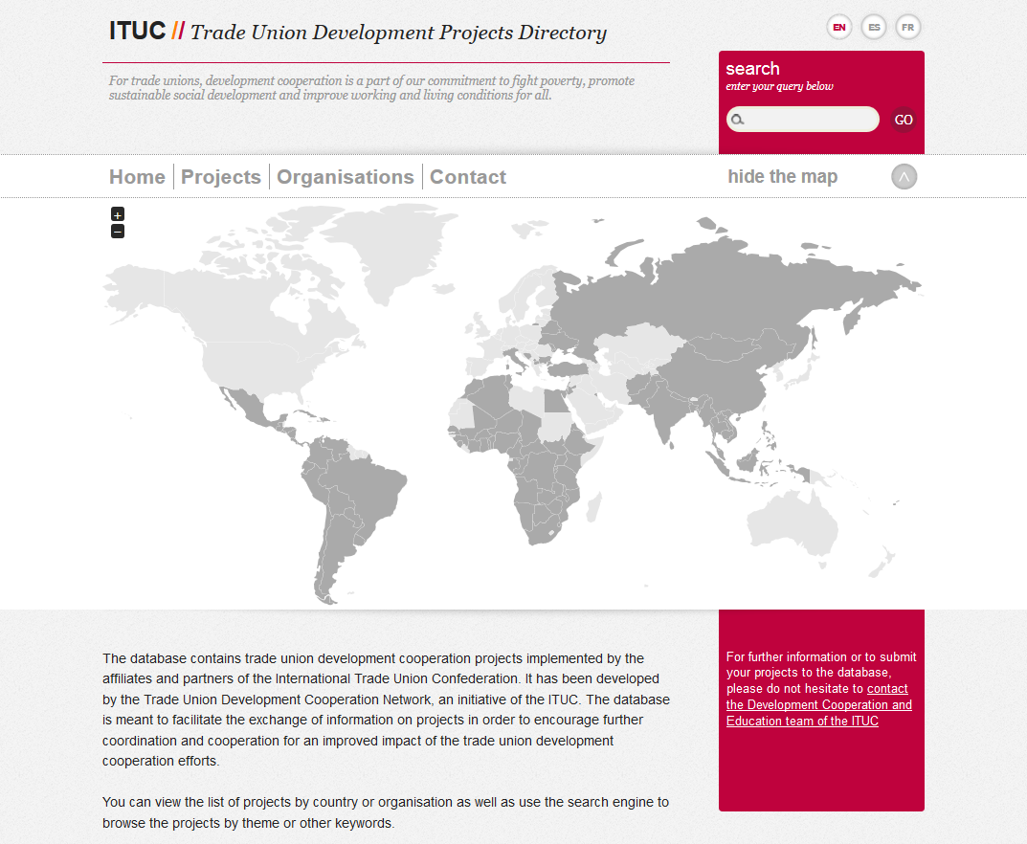

ANNEX 2: TUDEP and support materials

http://www.ituc-csi.org/tu-development-effectiness-profile

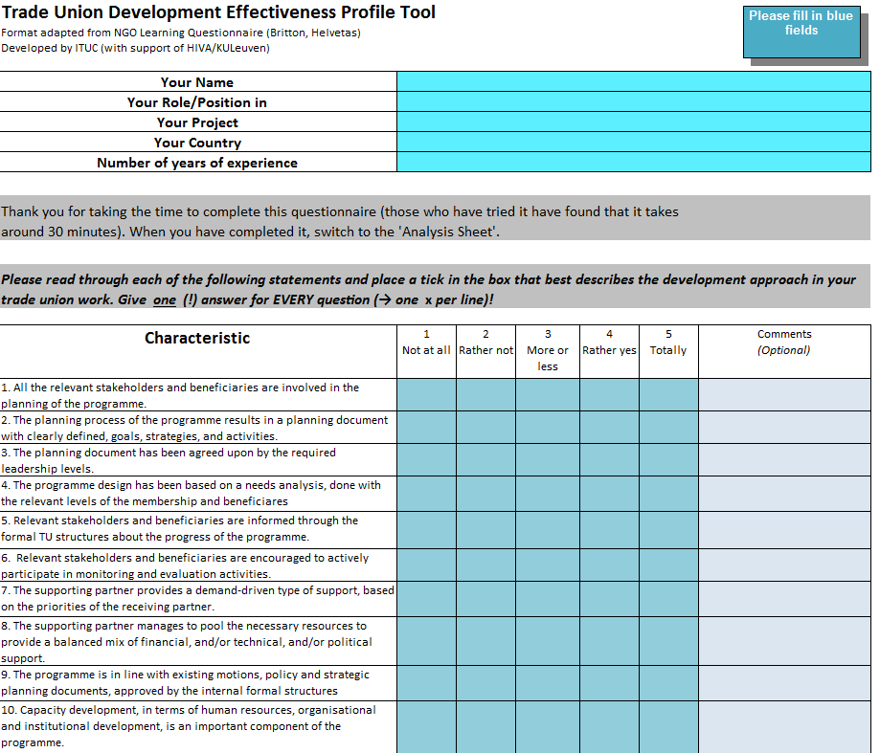
ANNEX 3: LIST OF PARTICIPANTS

No. | Participant | Organisation | Country
1 | Aleman Garcia Dalila Del Carmen | CST | Nicaragua
2 | Hovgaard Joergen | 3F | Denmark
3 | Aguilar Julia | FES | Central America
4 | Bassoli Sergio | CGIL | Italy
5 | Beresi Leticia | FGTB | Belgium
6 | Carcamo Idalmy Elizabeth | CUTH | Honduras
7 | Castillo Gerardo | UITA | Costa Rica
8 | Cirulli Simone | ISCOS | Italy
9 | Durán Victor | CSA | Costa Rica
10 | Escribano Marcela | CSN- Alternatives | Canada
11 | Gomez Olga | CTRN | Costa Rica
12 | González Vallejo Santiago | USO - SOTERMUN | Spain
13 | Jean Jony | CTH | Haiti
14 | Lada Mario | Convergencia sindical | Panama
15 | Lensink Frank | FOS-CA | Belgium
16 | Lisboa Antonio | CUT | Brazil
17 | Lopez Diego | CSI | Belgium
18 | Marmol Magdalena | CATS | El Salvador
19 | Massobrio Giulia | CSA | Brazil
20 | Monge Loria Jonatan | CMTC | Costa Rica
21 | Robles Jorge | UNT | Mexico
22 | Sambonino Patricio | SASK | Finland
23 | Simonetti Paola | CSI | Belgium
24 | Zacarias Victoriano | CGTG | Guatemala

ANNEX 4: AGENDA
Thursday 28/8
09:00 11:00 | Opening  - Inscription and welcome  - Opening  - Introduction to the activity and presentation of the methodology  - Introduction of the participants and their expectations
11:00 11:30 | Coffee / break
11:30 13:00 | Mapping trade union cooperation in the Central American and Caribbean subregion  - Presentation of the ITUC Projects Directory  - Presentation of the results of the mapping  - Questions and comments
13:00 14:30 | Lunch
14:30 15:30 | Trade Union Development Effectiveness Principles and TUDEP  - Presentation of the trade union development effectiveness principles: process, principles and relevance in trade union development cooperation work  - Presentation of the TUDEP tool
15:30  16:00 | Examination and assessment of trade union cooperation in Central America and the Caribbean based on the trade union development effectiveness principles and the TUDEP tool  - Individual work
16:00 16:30 | Coffee / break
16:30  18:00 | Examination and assessment of trade union cooperation in Central America and the Caribbean based on the trade union development effectiveness principles and the TUDEP tool  - Group work

Friday 29/8
09:00 11:00 | Presentation in plenary of the results of the examination and assessment of trade union cooperation in Central America and the Caribbean  - Presentation of results of the TUDEP tool  - Summary of the matters discussed in each group  - Identification of the main problems
11:00 11:30 | Coffee / break
11:30 13:00 | Development of mechanisms to improve trade union cooperation in the Central American and Caribbean subregion  - Group work
13:00 14:30 | Lunch
14:30  16:00 | Presentation and plenary discussion of the improvement mechanisms proposed and the establishment of implementation systems
16:00 16:30 | Coffee / break
16:30 18:00 | Conclusions, assessment of the seminar and close

