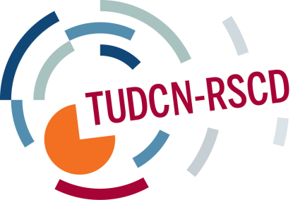

TRADE UNION DEVELOPMENT COOPERATION NETWORK
CALENDAR OF ACTIVITIES 2015
March, Brussels (tbc) | WG meeting on EU development polices
2-4 March, Panama City | Latin America regional development network meeting (focus on advocacy)
19-20 March, Brussels | Thematic seminar: OCA (organizational capacity assessment) frameworks
27-29 April, Florence | TUDCN General Meeting
11-13 May, New York | Thematic seminar on: global governance and Financing for Development
June | WG meeting on TUs Partnerships
September, Brussels | Open Coordination meeting
October, Paris | 2nd TU-OECD/DAC Forum
October, Buenos Aires | Latin America regional development network meeting (focus on partnerships)
November, Dakar | African regional development network meeting (focus on partnerships/advocacy)
December (tbc) | AP regional development network meeting (focus on partnerships

