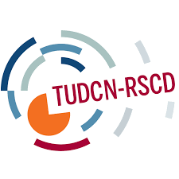

ATUDC Steering Committee Meeting
Lome - Togo, 6-7th October

Program

Day 1: Thursday, 6th October 2016
Time | Topic | Speaker/presenter/facilitator
9:00am | Opening Reflection/Meditation | Alex Nkosi
9:15 | Opening remarks | Kwasi Adu-Amankwah, GS, ITUC-Africa/Adrian Akouete, DGS, ITUC-Africa and Wellington Chibebe
9:45 | ATUDN work and recap of previous meetings | Hilma Mote, Executive Director, ALREI
10:00 | Health Break
10.30 | Overview on the Trade Union Development Cooperation Network (TUDCN): global strategy 2016-2020. | Diego López
11.30 | The implementation of Agenda 2030 in Africa: the role of regional and sub-regional institutions, and national governments | Alex Nkosi, EATUC, SATUCC, OTUWA
12.30 | Presentation and discussion on the results of the exploratory survey on trade union awareness and mobilization on Agenda 2030 | Hilma Mote/Alex Nkosi
13:00 | Lunch Break
14.00 | Towards a TUDCN strategy on Agenda 2030 | Joan Lanfranco  Diego López
15:00 | How can we move forward to implement Agenda 2030?  Group work: TU Engagement Experiences at National Level: Successes, Issues & capacity assessment | Alex Nkosi/Hilma, Participants
16:00 | Health Break
16:30 | Feedback and Group Discussions | Alex Nkosi
17:00 | End of Day 1
Day 2: Friday 7th October 2016
Time | Topic | Speaker/presenter/facilitator
9:00 | Focus on Agenda 2030 monitoring framework: Trade union national reports on SDGs implementation  Group work | Joan Lanfranco  Diego López
11:00 | Coffee Break
11:30 | GPEDC HLM2 Update and discussion | Diego López
12:00 | ATUDN communication and The TUDCN communication strategy | Alex Nkosi/Theo Morissey
13:00 | Lunch Break
14:00 | ATUDN Workplan | Alex
14:30 | Discussion and Adoption of the Workplan | Hilma Mote
15:00 | Modus Operandi: Roles and Responsibilities | Alex Nkosi
15:30 | Discussion and Adoption of the Modus Operandi | Alex Nkosi/Hilma Mote
16:00 | Health Break
16:30 | Conclusions and closure | Kwasi Adu-Amankwah, GS, ITUC-Africa/Adrian Akouete, DGS, ITUC-Africa and Wellington Chibebe

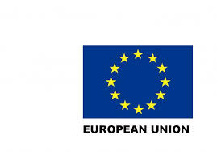
This project is Co-funded by the European Union.

