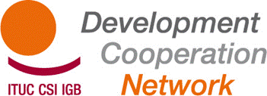

TUDCN Working Group on EU Policy & Instruments Brussels 16-17 April
International Trade Union House (ITUH)
Bd. du Roi Albert II, 5 – 1210 Brussels
Room E, 1° floor

AGENDA

MONDAY 16

14.00h INTRODUCTORY SESSION

14.30h BACKGROUND ON THE PROCESS: Consultation on ‘Civil society Organisations in Development’
Mr Angelo Baglio, Head of Unit - Relations with Civil Society and Coordination, DEVCO D2

15.15h COFFEE BREAK

15.30h WORKING GROUPS CONTRIBUTIONS on the EC consultation paper

18.00h END OF DAY 1

TUESDAY 17
9.30h: Presentation of WGs results and plenary discussion
11.00h COFFEE BREAK

11.30h UPDATES and EXCHANGE OF VIEWS on DCI proposal
Mrs Tessel van Westen, assistant to Thijs Berman, MEP Development Committee

UPDATES on Structured Dialogue Follow up – Policy Forum on Development

13.00 END of the SEMINAR and LUNCH

