HIV/AIDS, health, climate change and sustainable development – making the links for the trade union response
Background paper on HIV/AIDS for the Rio+20 Conference 20-22.06.2012

This note is designed to examine critical links between health, the environment, and development in order to place trade union HIV/AIDS advocacy within the context of social equity and sustainable livelihoods demands for the outcomes of the Rio+20 UN Conference in 2012.

HIV/AIDS, Climate Change and Vulnerability
Population health is not merely the absence of disease. The right to health encompasses the right to housing, sanitation, literacy, environmental quality and social capital (WHO and UN).
Every year 20 mln people outside of wealthiest countries die of preventable or treatable diseases. 80 percent of global expenditure on health is spent in the OECD countries which account for 18 percent of world’s population, but which benefit from more than 60 percent of the global health workforce. The whole of Africa accounts for 2,7 percent of the global health workforce (2006 WHO).
Environmental destruction boosts the growth of climate-responsive diseases (such as malaria, heat stroke, dengue, yellow fever, cholera) and pollution-responsive diseases (such as cancer, respiratory diseases, diarrhea, malnutrition). Developing nations have contributed the least to the build-up of greenhouse gas emissions but they will be hit the hardest by the consequences, including the burden of disease. Global health threats will amplify health disparities between rich and poor parts of the world and will interact with phenomena such as migration, food shortages and empoverishment, forcing people to indulge in survial behaviours that they would not have otherwise engaged in.
Governments should share the sense of urgency to address continuing deterioration of ecosystems and economies and not do this in isolation from action on ill health, including AIDS (as initiated in 1992 – Agenda 21, Preamble, 1992 Rio Declaration Principle 1, Chapter 6 (12)(j), Chapter 13 (a) (iii)).

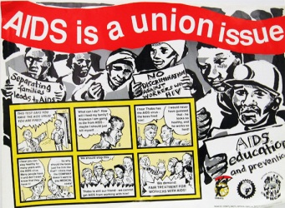 T
The ITUC has worked on AIDS and workplace issues since the 1980’s, promoting and supporting national and international efforts on HIV in and through the world of work. ITUC HIV/AIDS Program works to implement the 2010 ITUC 2nd World Congress Resolution on HIV/AIDS. The Program supports affiliates in advocating for enabling legal and policy environments on HIV and socio-economic rights at the national, regional and global levels.

Global Health Inequalities
These are examples of global injustice that should be intolerable if there were genuine commitment to universal human rights, social equity and achieving sustainable development for all:

The impact of AIDS on sustainable development

The impact of environmental change on HIV/AIDS and health

How to integrate HIV/AIDS and healh equity considerations into the Rio+20 themes, for the sake of consolidated trade union advocacy?

Sustainable livelyhoods
The higest attainable standard of health can only be fulfilled in a broader context of social justice, realization of all human rights, sustainable environment and fair economic system. Health justice is a part of social equity and environmental justice and these 3 elements must form the heart of sustainable development and of the outcomes of the Rio+20 UN Conference in 2012.

Social protection for all
Social protection is a global opportunity to confront the global economic crisis, as well as global environmental crisis and its effects on people - and accelerate recovery. It has many potential entry points to influence health outcomes. But social protection is not a magic bullet; challenges, risks and unknowns remain. For social protection to work, especially for prevention, multisectoral frameworks are required. HIV/AIDS debate on Rio+20 and social protection could bring added value in posing a question how to increase the transformative capacity of social protection (equal rights, social justice legislation), apart from its potential preventative (e.g. insurance) and protective (e.g. social assistance, social services) capacities.

Applying a MDGs/SDGs approach
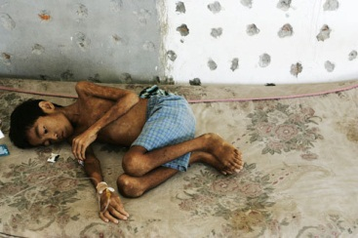
Applying a AIDS-and-MDGs/SDGs approach is about promoting strategies where simultaneously addressing AIDS together with other development goals could be more effective than tackling them in isolation. Access to education, conservation of natural resources, poverty reduction, reducing gender-based violence, and improving health, community and employment systems are all key areas where there are synergies between HIV-specific efforts and action on other development goals.
Environmental destruction boosts the growth of climate-responsive diseases and pollution-responsive diseases. All of them interact with AIDS.

Looking Forward: Rio+20, MDGs 2015 and Beyond
Elevating HIV to an issue o f high politics (MDG 6, UNGASS) and establishing a clear focus on involvement of civil society, South-South cooperation, national ownership, global financing mechanisms and accountability - prove to yield lasting benefits in the AIDS global response. The last 10 years of global action on AIDS – in the form of enhanced, global political commitment and accountability for a human development – offer important lessons for the sustainable development process. For trade union advocacy, possible programatic responses include:

- Mapping the HIV epidemic in relation to the broader MDG/SDG and development context;

- Exploring cross-MDG/SDG strategies – strengthening alliances between trade union AIDS advocates and those working in areas such as poverty, education, gender equality and environment;

- Generating trade union AIDS and MDG/SDG external partnerships.

____________________________________
For more information please contact: Zuzanna Muskat-Gorska, Global Trade Union HIV/AIDS Coordinator, ITUC: zuzanna.gorska@ituc-csi.org.

Preamble to the Constitution of the World Health Organization; UN General Comment No. 14 (2000) (Point 3).

